 | VIỆN ĐÀO TẠO QUỐC TẾ FPT  DATA SCIENCE WITH AI-ML |         

AI Job Market Salary Prediction
Technical Specification Design - Semester II
Lecturer: Ms. Nguyen Ha Vy
Course: I1.2510.E0
Group: 03
Member: | Full Name |  | Student ID
 | 1. | Huynh Minh
 | 2. | Ta Gia Hien
 | 3. | Gia Bao
 | 4. | Nguyen Kim Ngan | FIS00016
- September 2026 -
TABLE OF CONTENTS
A - PROJECT INTRODUCTION 4
A.1. Project Scope 4
A.2. Pipeline Overview 4
A.3. Scope and Limitations of the Project 5
B - SYSTEM ARCHITECTURE & TECHNICAL REQUIREMENTS 6
B.1. Hardware and Infrastructure Requirements 6
B.2. Software Environment 6
B.3. Technology Stack 6
C. DESIGN PROCESS 7
STAGE 1. Load Data 7
STAGE 2. Project Scope & Initial Inspection 9
STAGE 3. Data Quality Check 10
STAGE 4. Corrupted Row Removal 11
STAGE 5. Contradictory-Feature Investigation (Điều tra đặc trưng mâu thuẫn) 11
STAGE 6. Feature Selection & Leakage Preventaion 16
STAGE 7. Correlation Encoding & Analysis 24
STAGE 8. Train-Test Split 28
STAGE 9. Model Training & Comparison 29
.3 Baseline and Candidate Model Ladder 29
6.4 Hyperparameter Tuning Rules 30
6.5 Evaluation Metrics 30
6.6 Model Promotion Criteria 30
STAGE 10. Best Model Selection & Feature Importance Review 32
STAGE 11. Save Deployable Pipeline + Metadata 32
STAGE 12. Streamlit Salary Prediction Dashboard 33
D – CODE IMPLEMENTATION 34
D.1. salary_predict_corrected.ipynb File 34
D.2. app.py File — Streamlit Salary Predictor 44
E – INSTALLATION & HOW TO RUN THE PROJECT 50
Step 1: Install the required libraries 50
Step 2: Run the data cleaning, EDA & model-training notebook 50
Step 3: Launch the Streamlit dashboard 50
F - CONCLUSION AND FUTURE DEVELOPMENT 51
G - REFERENCES 62
H - TASK ASSIGNMENT TABLE 62

A - PROJECT INTRODUCTION
(PIC = Bảo)

A.1. Project Scope
1.1. Project Overview:
This project focuses on AI Job Market Data Cleaning, Exploratory Data Analysis, and Salary Prediction Modelling, demonstrating a careful, skeptical approach to validating a dataset before trusting it for machine learning.
1.2. Expected Outcomes:
A systematic data-quality-first cleaning and modelling framework is required to convert raw job postings into a clean, trustworthy, and deployable salary-prediction pipeline.
Regression models are trained and compared.
The best model is packaged as a deployable artifact, and an interactive Streamlit dashboard is built to predict AI job salaries in real time.
1.3. Problem Statement:
Raw job-market data presents several challenges:
- Columns that directly leak the target variable (e.g. salary ranges derived from the same underlying salary):
- Presence of columns that leak the target variable (salary_min_usd, salary_max_usd, salary_tier) vs annual_salary.
- Two experience-related columns (experience_level and years_of_experience) that tell contradictory stories about pay.
- Corrupted values hidden inside otherwise clean-looking categorical columns.
- Contradictory features that appear to measure the same concept but disagree with each other
- High-cardinality categorical columns (many job titles, cities, countries).
- No safe, reusable encoding strategy for turning a single new form submission into model-ready features.

A.2. Pipeline Overview

Stage | Name | Operational purpose
1 | Load Data | Fingerprint the raw CSV and preserve row/column counts.
2 | Project Scope & Initial Inspection | Validate target, schema, dtypes and descriptive statistics.
3 | Data Quality Check | Check nulls, duplicates, hidden missing tokens and cardinality.
4 | Corrupted Row Removal | Remove the one row where the header value leaked into job_category.
5 | Contradictory-Feature Investigation | Audit experience mismatch and salary metadata consistency.
6 | Feature Selection & Leakage Prevention | Block identifiers, target-adjacent salary fields and redundant flags.
7 | Correlation Encoding & Analysis | TRAIN-only one-hot/ordinal/multi-hot diagnostics and target correlation.
8 | Train-Test Split | Reserve 2026-03 as locked test; fit preprocessing on TRAIN/DEV only.
9 | Model Training & Comparison | Compare five regression families with temporal CV.
10 | Best Model & Importance Review | Tune selected family, open locked test once, review importance.
11 | Save Deployable Pipeline + Metadata | Serialize preprocessing + model bundle and inference contract.
12 | Streamlit Dashboard | Use the same bundle for authenticated interactive inference.

A.3. Scope and Limitations of the Project
- Critical scientific interpretation: The dataset can support an academic exercise in supervised regression and ML systems design. It does not, by itself, support a claim that the learned relationships are faithful real-world salary economics. Strong feature importance must therefore be presented as dataset-fit behavior and tested with ablations.

B - SYSTEM ARCHITECTURE & TECHNICAL REQUIREMENTS
(PIC = Duy AI)

B.1. Hardware and Infrastructure Requirements

B.2. Software Environment

B.3. Technology Stack
Using Python libraries such as Pandas, NumPy, Matplotlib, and Scikit-learn.
Tool / Technology | Purpose
Python | Core programming language
Pandas | Data loading and manipulation
NumPy | Numerical computations
Matplotlib | Data visualization
Scikit-learn | Preprocessing pipelines, models, evaluation metrics
Joblib | Saving and loading the trained pipeline artifacts
CSV Dataset | Data storage (ai_jobs_market_2025_2026.csv)
Jupyter Notebook | EDA & model development
Streamlit | Interactive salary-prediction dashboard

C. DESIGN PROCESS
12 | 12-Stage Pipeline  The technical design is implemented as a reproducible sequence from raw ingestion to Streamlit inference.
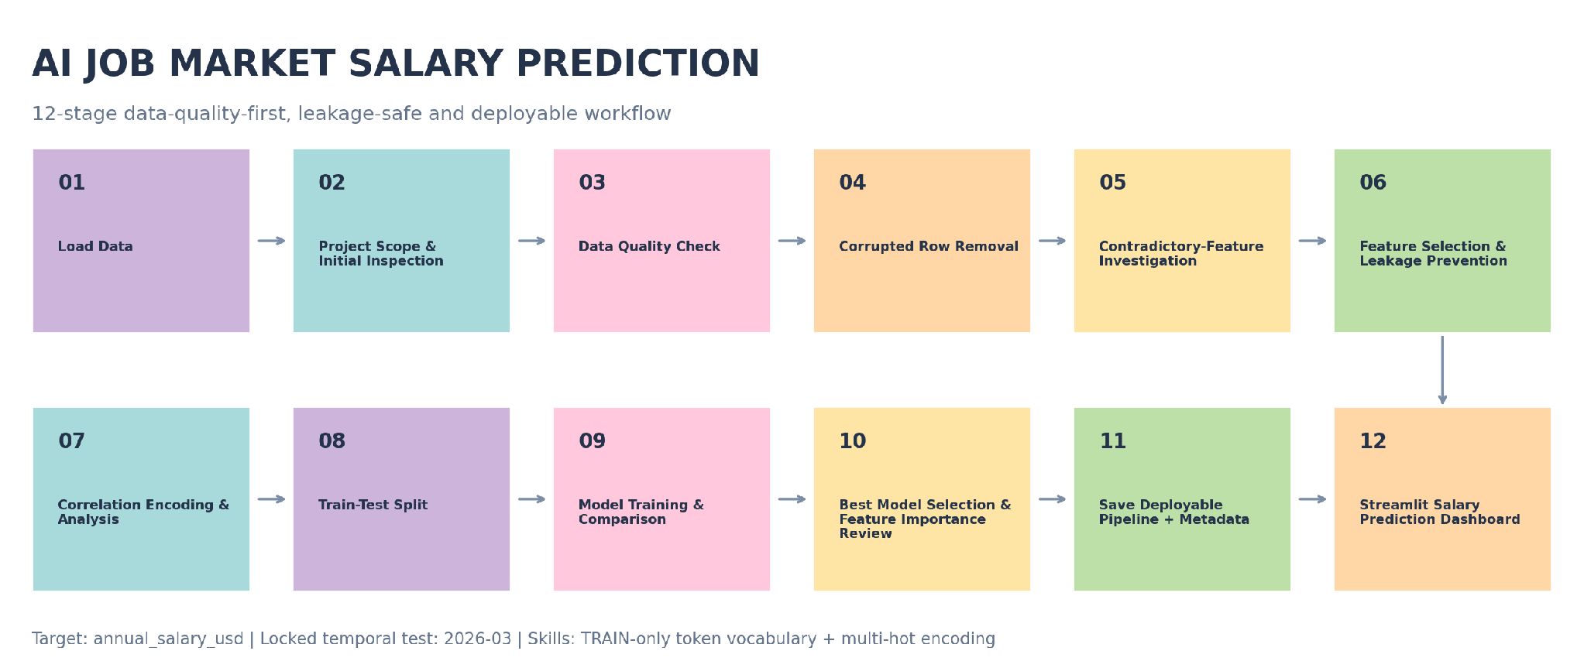
Leakage control Although Stage 8 is the formal split stage in the 12-stage academic presentation, the locked-period mask is declared before any target-aware diagnostics. All learned transforms and the 93-token skill vocabulary are fit on development/TRAIN data only.

STAGE 1. Load Data
1.1. To load raw AI Job Market Dataset:
Property | Observed value
File | ai_jobs_market_2025_2026.csv
Rows x columns | 1,500 x 25
File size | 378,914 bytes
Period | Jan 2025 to Mar 2026

1.2. Exploratory Data Analysis (EDA) and understand a real-world-style AI job market dataset:

Data Profiling:
# | Raw column | Canonical column | Logical type | Observed domain / range | Data rule | ML role
1 | job_id | job_id | String / ID | 1,500 unique; dạng AIJOB0001… | NOT NULL, UNIQUE, regex ^AIJOB\d{4}$ | BLOCK, unique posting identifier
2 | job_title | job_title | Nominal categorical | 25 categories | NOT NULL; unknown category được flag | KEEP
3 | AI Engineering | job_category | Nominal categorical | 13 raw values; 12 valid + 1 corrupted | "job_category" là invalid value → loại row / quarantine | KEEP after cleaning
4 | experience_level | experience_level | Ordinal categorical | Entry / Mid / Senior / Lead | NOT NULL; semantic audit với years | ABLATION
5 | years_of_experience | years_of_experience | Integer numeric | 1–15 | integer ≥ 0; semantic consistency check | ABLATION
6 | education_required | education_required | Ordinal categorical | 5 levels | explicit ordered categories | KEEP
7 | annual_salary_usd | annual_salary_usd | Integer numeric | 90,000–384,000 | > 0; NOT NULL | TARGET
8 | salary_min_usd | salary_min_usd | Integer numeric | 90,000–180,000 | > 0; min ≤ max | BLOCK — target adjacent
9 | salary_max_usd | salary_max_usd | Integer numeric | 180,000–320,000 | > 0; max ≥ min | BLOCK — target adjacent
10 | city | city | Nominal categorical | 20 cities | NOT NULL; unknown → OOD flag | KEEP / ABLATE
11 | country | country | Nominal categorical | 14 countries | NOT NULL; validate city-country pair | KEEP / ABLATE
12 | remote_work | remote_work | Nominal categorical | On-site, Hybrid, Fully Remote | closed categorical domain | KEEP
13 | company_size | company_size | Ordinal/nominal categorical | 5 categories | controlled vocabulary | KEEP
14 | industry | industry | Nominal categorical | 12 industries | controlled vocabulary | KEEP
15 | required_skills | required_skills | Multi-label text | 1,500 unique strings; | delimited | tokenize only after split; train-only vocabulary  thêm một cột đánh số lượng skill_count | PHASE 2
16 | ai_salary_premium_pct | ai_salary_premium_pct | Float numeric | 3.0–18.0 | provenance/availability check | CONDITIONAL
17 | demand_score | demand_score | Integer numeric | 68–98 | numeric range validation | KEEP / ABLATE
18 | demand_growth_yoy_pct | demand_growth_yoy_pct | Float numeric | 5.0–87.8 | provenance/availability check | CONDITIONAL
19 | benefits_score_10 | benefits_score_10 | Integer numeric | 6–10 | integer, recommended domain 0–10 | KEEP
20 | posting_year | posting_year | Integer / temporal | 2025–2026 | required for temporal split | SPLIT / CONDITIONAL X
21 | posting_month | posting_month | Integer / temporal | 1–12 | integer ∈ [1,12] | SPLIT / CONDITIONAL X
22 | is_senior | is_senior | Boolean / binary | 0,1 | exact derived flag | BLOCK
23 | is_remote_friendly | is_remote_friendly | Boolean / binary | 0,1 | exact derived flag | BLOCK
24 | is_llm_role | is_llm_role | Boolean / binary | 0,1 | exact derived flag by role family | BLOCK
25 | salary_tier | salary_tier | Ordinal categorical | 5 tiers | salary-derived semantic audit | BLOCK — target leakage

STAGE 2. Project Scope & Initial Inspection
- Scope: question & expectation: This project focuses on AI Job Market Data Cleaning, Exploratory Data Analysis, and Salary Prediction Modelling, demonstrating a careful, skeptical approach to validating a dataset before trusting it for machine learning - AI Job Market Salary Prediction.
- Understand dataset dimensions, dataset preview and shape inspection (df.head(), df.info()) and shape, dtypes
- descriptive statistical summaries (df.describe())
- profiling/ dictionary, describe
- data schema & rule
- Formal Task Definition
Component | Definition
Task type | Supervised regression (using unsupervised regression?)
Modeling unit | One job posting / one CSV row after data-quality gates
Target y | annual_salary_usd, integer USD/year
Input X | Only features known at prediction time and admitted by feature policy
Prediction moment | Before annual_salary_usd is known/finalized
Primary output | Predicted annual salary in USD
Recommended secondary output | Empirical prediction interval + OOD/review flag + top model drivers
Primary intended user | Analyst / student / decision-support user exploring salary benchmarks

- Target Distribution:
- annual_salary_usd ranges from $90,000 to $384,000;
- mean = $194,892;
- median = $180,000;
- standard deviation = $66,507.
- The IQR rule flags 8 high-end values above $373,500; these are not automatically removed because salary extremes can be legitimate. Outlier handling must be evidence-based and fit on TRAIN only.
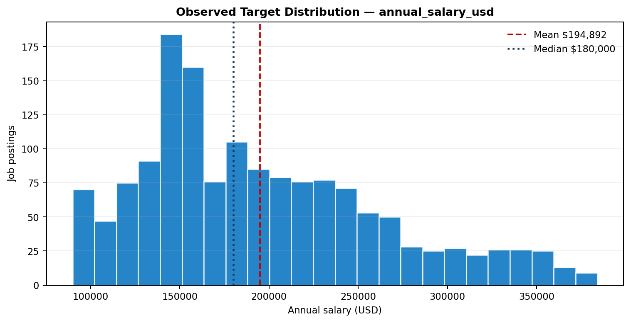
Figure 1. salary target distribution from the raw CSV.

STAGE 3. Data Quality Check
- detect nulls and duplicate records
- sanity-check every categorical column's actual values: A full value_by_value sanity check of every categorical column — not just null/duplicate counts — was run, since those two checks alone miss corrupted values sitting inside otherwise valid-looking columns

STAGE 4. Corrupted Row Removal
- The AI Engineering column contained a value of "job_category" (count = 1, job_id AIJOB1205) — the column header itself had leaked into the data as a row value. This is exactly the kind of corruption that .isnull() and .duplicated() cannot catch, and it would have silently distorted any encoding or correlation work downstream.
- Since this affected only 1 row out of 1,500, the row was dropped outright rather than guessed or imputed, reducing the dataset from 1,500 to 1,499 rows.

Issue | Observed evidence | Magnitude | Required action
Categorical corruption | AI Engineering contains literal value "job_category" for AIJOB1205. | 1 / 1,500 | Remove row; do not impute an invented domain.

- Zero duplicate rows were found.

STAGE 5. Contradictory-Feature Investigation (Điều tra đặc trưng mâu thuẫn)
- To investigate contradictory features tell a consistent story before trusting either of them.

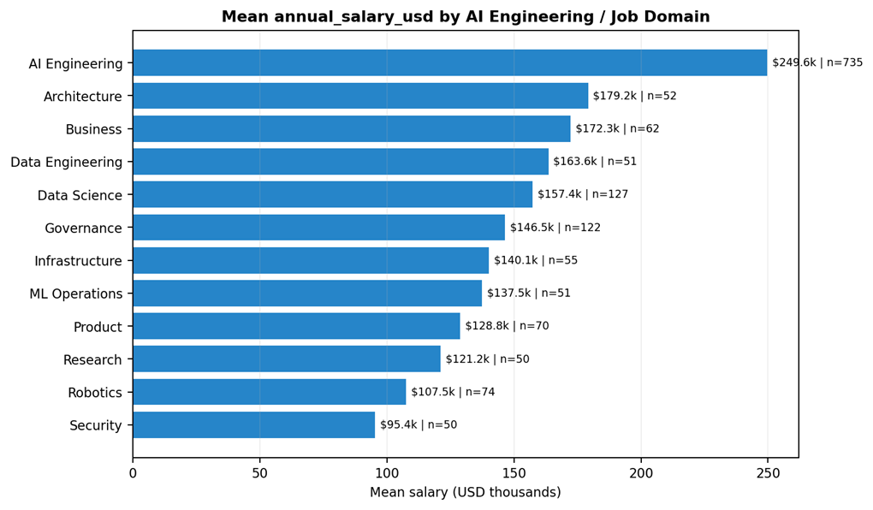
Figure 2a. mean salary by source job-domain field; the dominant domain-level separation is a synthetic-risk signal, not causal proof.

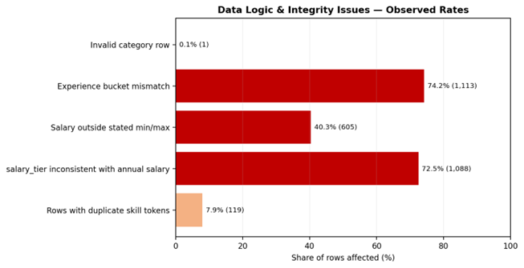
Figure 2b. share of rows affected by selected logic/integrity findings.

- Critical scientific interpretation. The dataset can support an academic exercise in supervised regression and ML systems design. It does not, by itself, support a claim that the learned relationships are faithful real-world salary economics. Strong feature importance must therefore be presented as dataset-fit behavior and tested with ablations - experience_level & years_of_experience vs target annual_salary_usd.

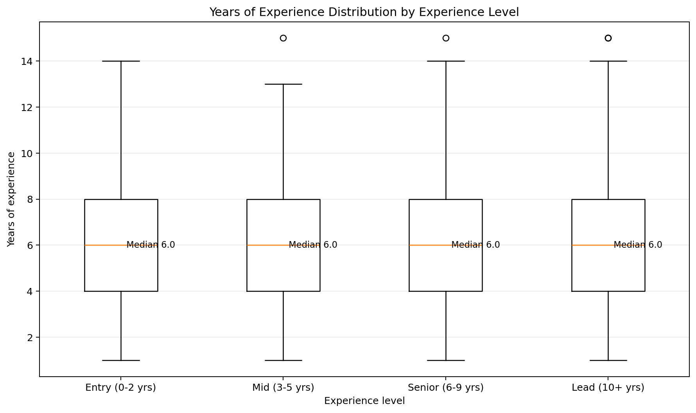
Figure 2c. year of experience distribution by experience level.

Mean Salary by experience_level (categorical bucket)
- Entry (0–2 yrs): ≈ $194,837
- Mid (3–5 yrs): ≈ $196,091
- Senior (6–9 yrs): ≈ $195,826
- Lead (10+ yrs): ≈ $193,037
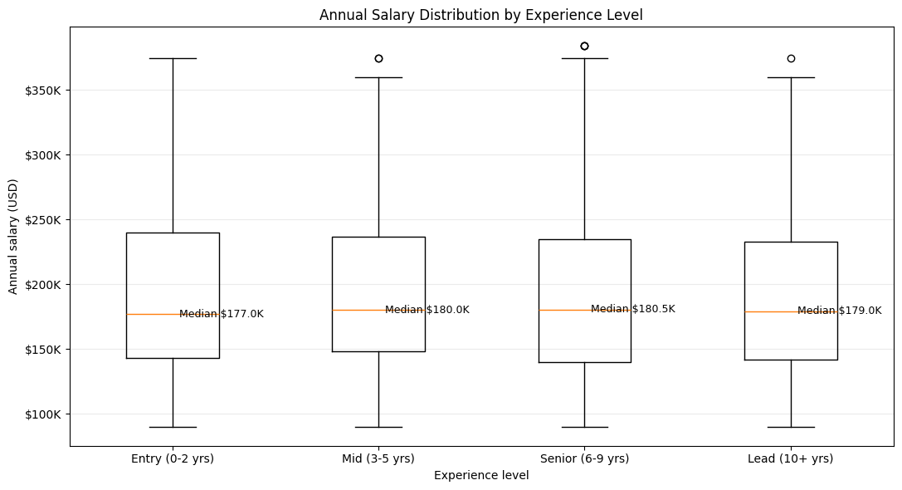
Figure 3. annual salary distribution by experience level.

Mean Salary by years_of_experience (raw numeric, selected values)
- 1 year: ≈ $325,800
- 5 years: ≈ $214,152
- 10 years: ≈ $132,020
- 15 years: ≈ $90,000
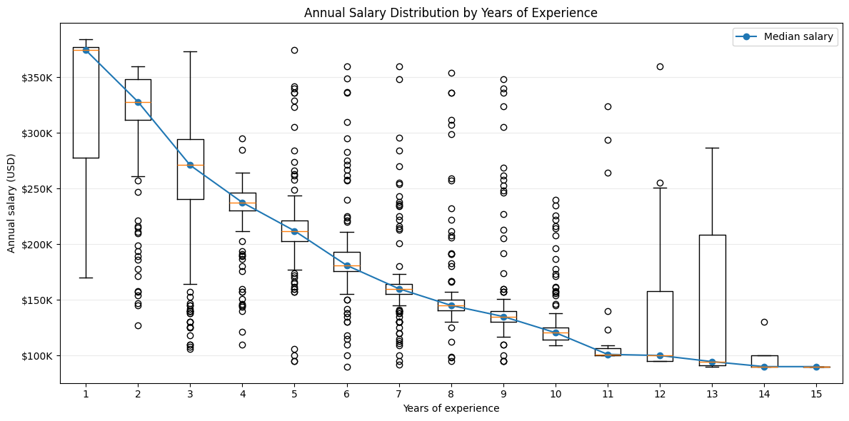
Figure 4a. annual salary distribution by years of experience.

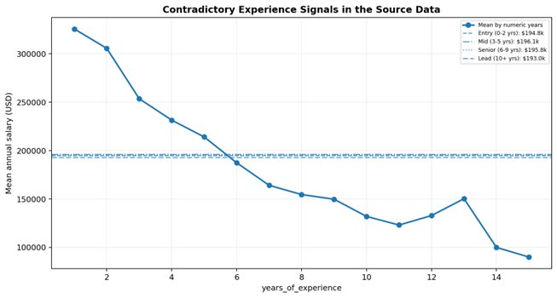
Figure 4b. years_of_experience shows a strong downward salary pattern while experience_level means are nearly flat.

Finding: experience_level shows salaries essentially flat across all four buckets (~$193k–$196k), while years_of_experience shows a strong downward trend. These two columns directly contradict each other and cannot both be reliable real-world signals.

Ablation study: Decision logic of Stage 5
years_of_experience
│
├─ Strong CV predictive value
├─ Strong OOT predictive value
├─ Granular numeric information
└─ KEEP WITH DOMAIN-VALIDATION FLAG
│
▼
annual_salary_usd
experience_level
│
├─ No standalone predictive value
├─ 74.2% logical inconsistency
├─ Redundant when logically consistent
├─ Apparent RF lift comes from contradiction
└─ DROP / QUARANTINE
Decision: this was treated as a data quality issue (most likely a synthetic-data generation artifact) rather than something to encode around silently. years_of_experience was kept as the more granular feature, experience_level was dropped as redundant and contradictory, and this relationship was flagged for cautious interpretation rather than trusted as a genuine pay-for-experience signal in any later write-up.
Issue | Observed evidence | Magnitude | Required action
Experience semantic mismatch | experience_level bucket disagrees with years_of_experience bucket. | 1,113 / 1,499 (74.2%) | Quarantine both as a contradictory feature family; run ablation and require provenance before semantic interpretation.

STAGE 6. Feature Selection & Leakage Preventaion
(drop leakage & unused columns)
6.1. Study feature correlation with the target variable:
A sorted bar chart of the top 25 features by absolute correlation with annual_salary_usd was plotted (a full heatmap becomes unreadable once job_title/city/etc. are one-hot encoded into 90+ columns).

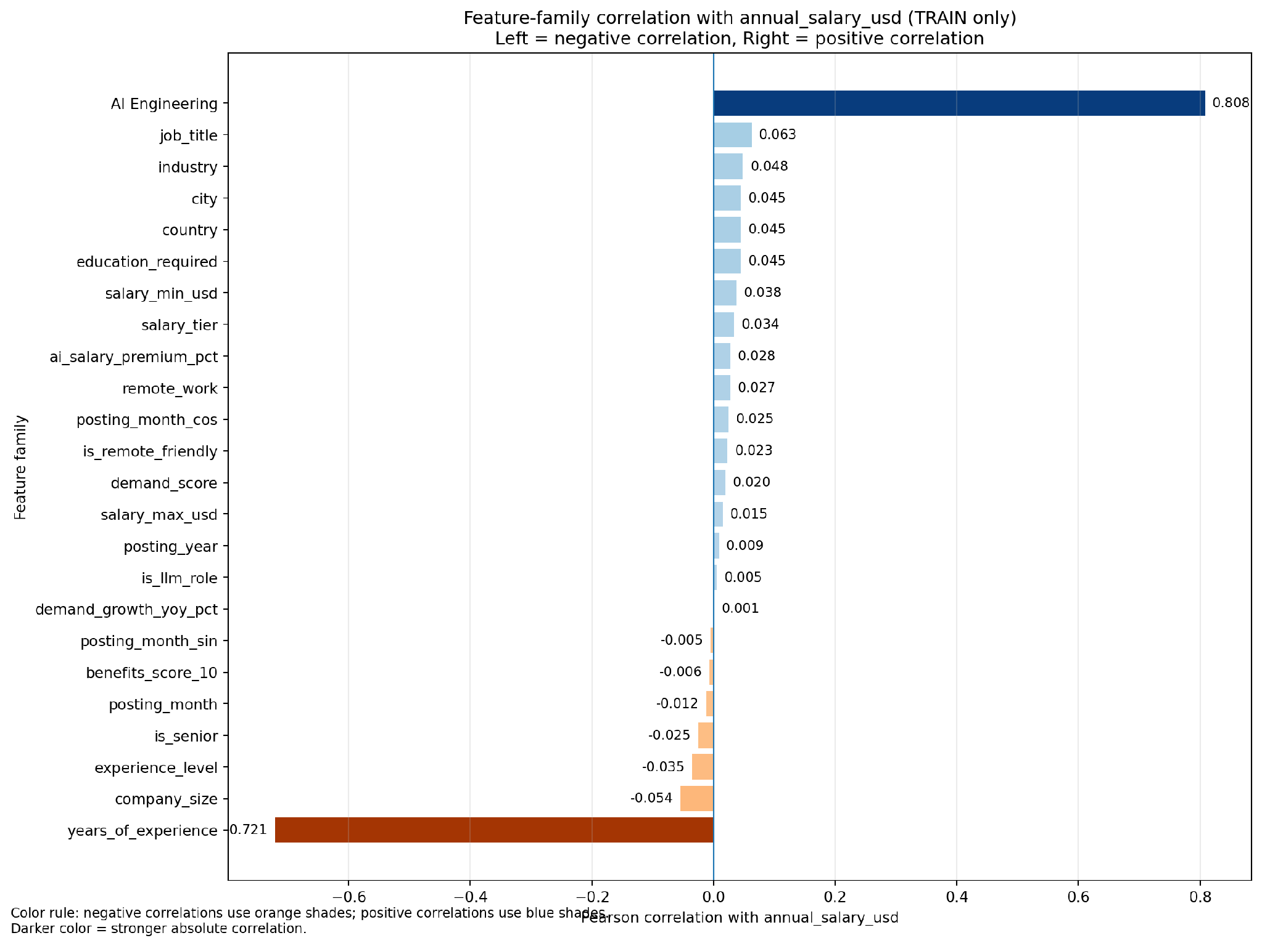
Figure 5. feature-family correlation on Train.

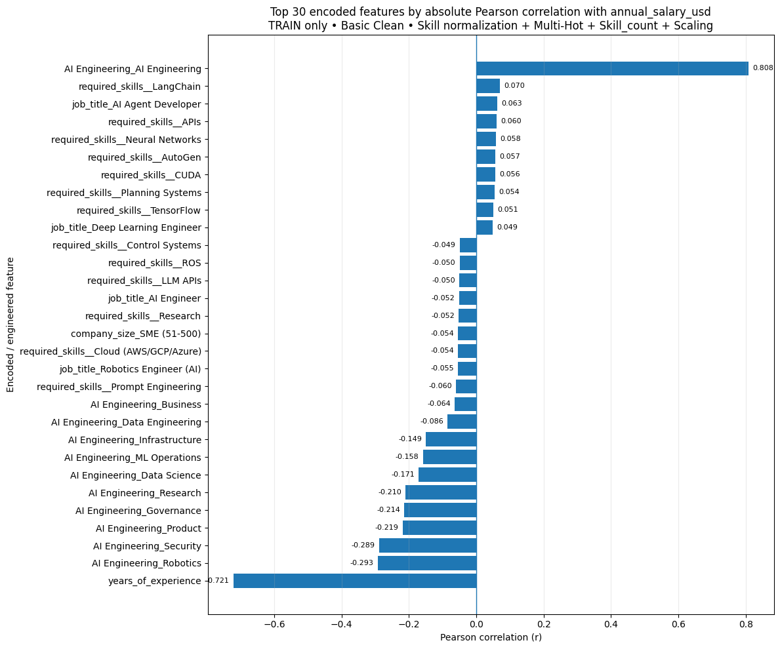
Figure 6. top 30 features by Pearson correlation on Train.


Figure 7. top 30 features by Pearson correlation on Train dataset.

Key Correlation Findings
- Strongest positive: job_category (old name = AI Engineering) ≈ +0.808 — belonging to this domain is associated with substantially higher pay.
- Strongest negative: years_of_experience ≈ −0.721 — consistent with the contradictory/synthetic-looking pattern flagged in stage 5.
- Other negative signals: AI Engineering_Robotics ≈ −0.293, AI Engineering_Security ≈ −0.289, AI Engineering_Product ≈ −0.219, AI Engineering_Governance ≈ −0.214
Because one-hot dummy columns are binary indicators, their correlation with salary is directly interpretable — it reflects whether belonging to that specific category is associated with higher or lower pay, unlike a single arbitrary LabelEncoder scale that would mix categories along one meaningless numeric axis.

6.2. Correlation analysis against the target variable: Columns that either leak the target or add no modelling value were removed:
- job_id — identifier, not a feature
Issue | Observed evidence | Magnitude | Required action
Feature functional dependency | job_title -> salary_min_usd, salary_max_usd and demand_score exactly (one value per title). | 25/25 titles | Avoid double-counting redundant features; use ablations.

- experience_level — redundant with, and contradicts, years_of_experience (see STAGE 5)
- salary_min_usd, salary_max_usd — leak the target (derived from the same salary structure)
- salary_tier — leaks the target (a binned version of it)

Issue | Observed evidence | Magnitude | Required action
Salary range inconsistency | annual_salary_usd is below salary_min_usd or above salary_max_usd. | 605 / 1,500 (40.3%) | Treat min/max as target-adjacent metadata, not trusted constraints.
Salary tier inconsistency | salary_tier does not match annual_salary_usd band by label definitions. | 1,088 / 1,500 (72.5%) | Block from primary X and do not use as target derivative.

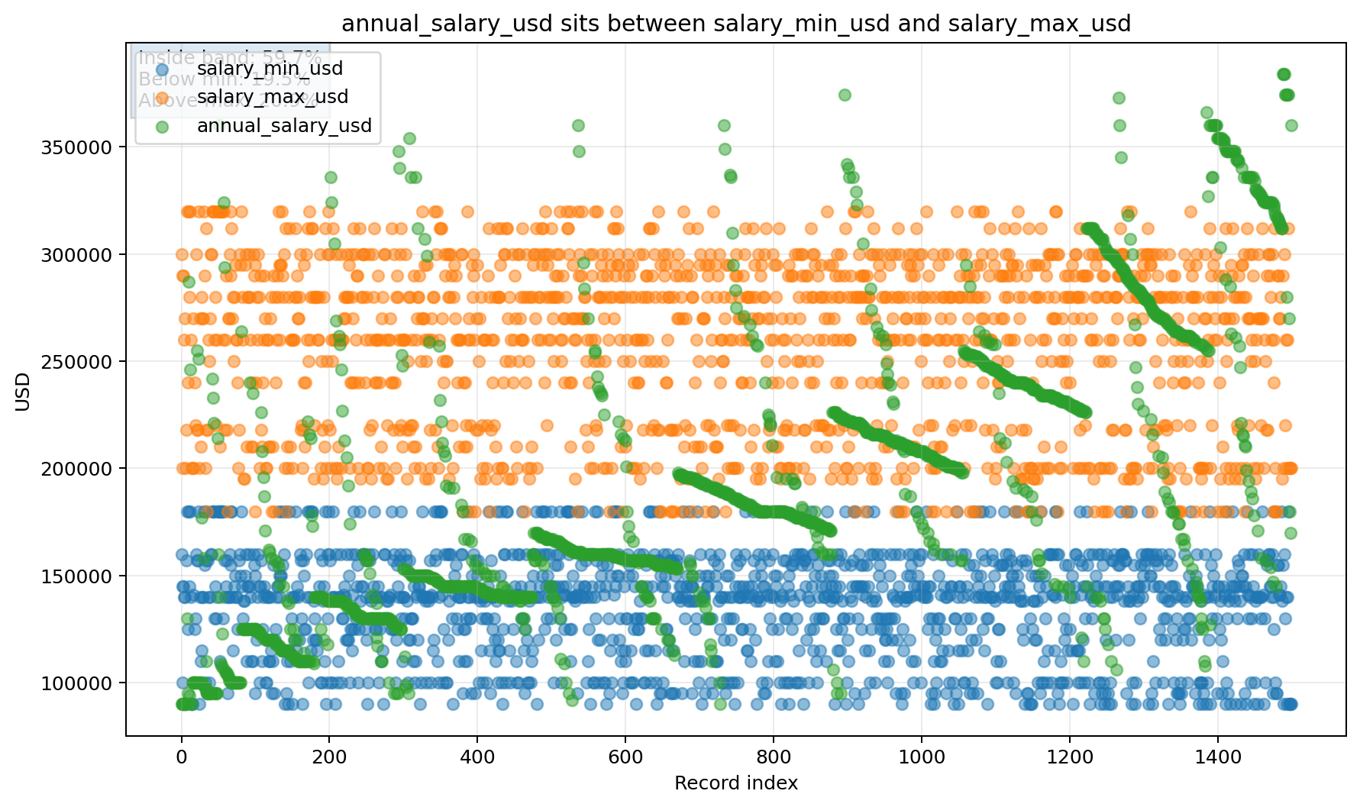
Figure 8a. salary range inconsistency.

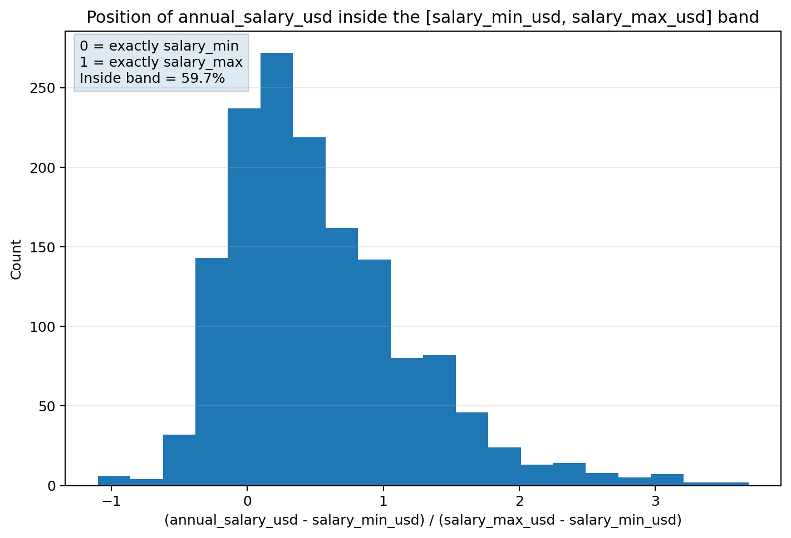
Figure 8b. salary range inconsistency ~40.3%.

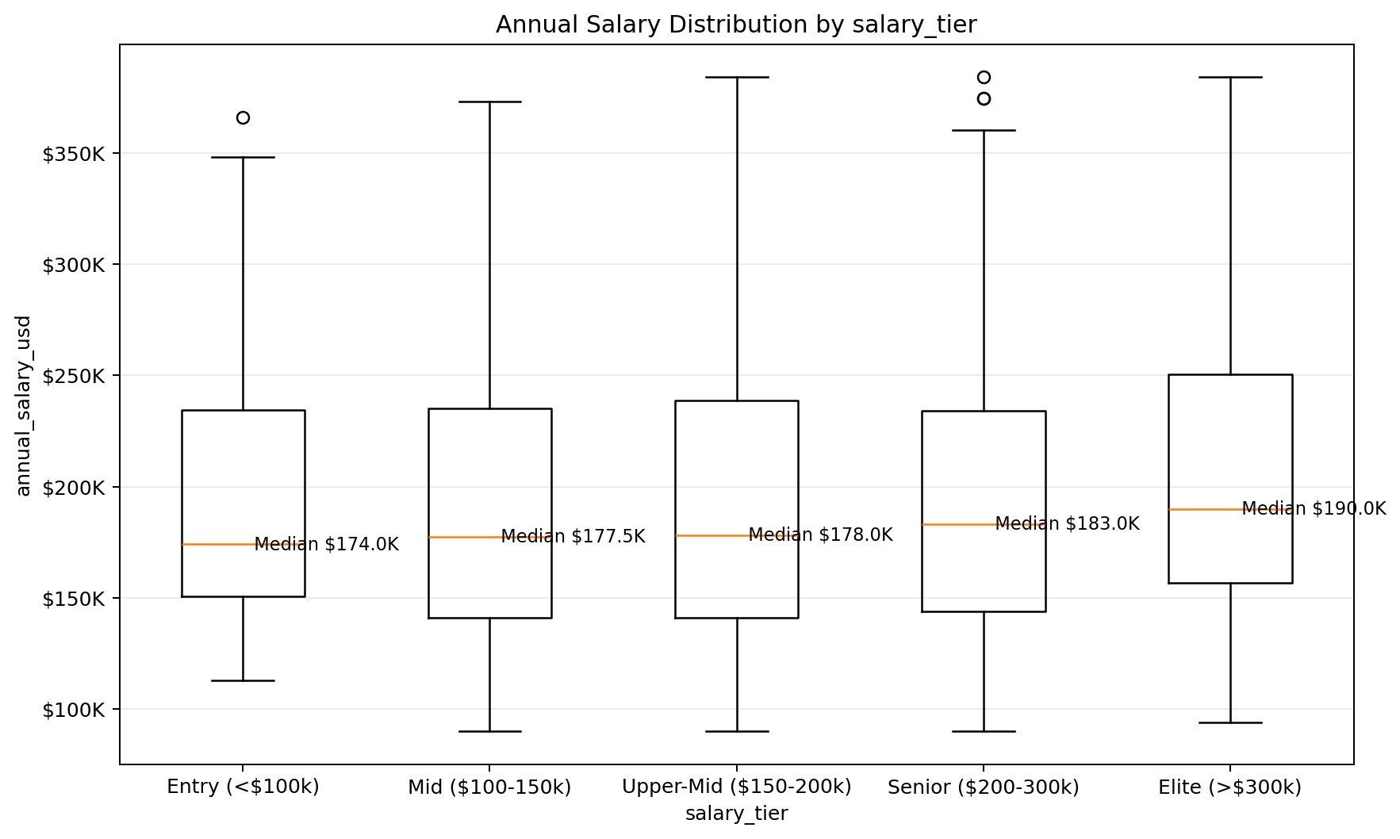
Figure 9. salary tier inconsistency.

- required_skills — free text, would need separate NLP treatment

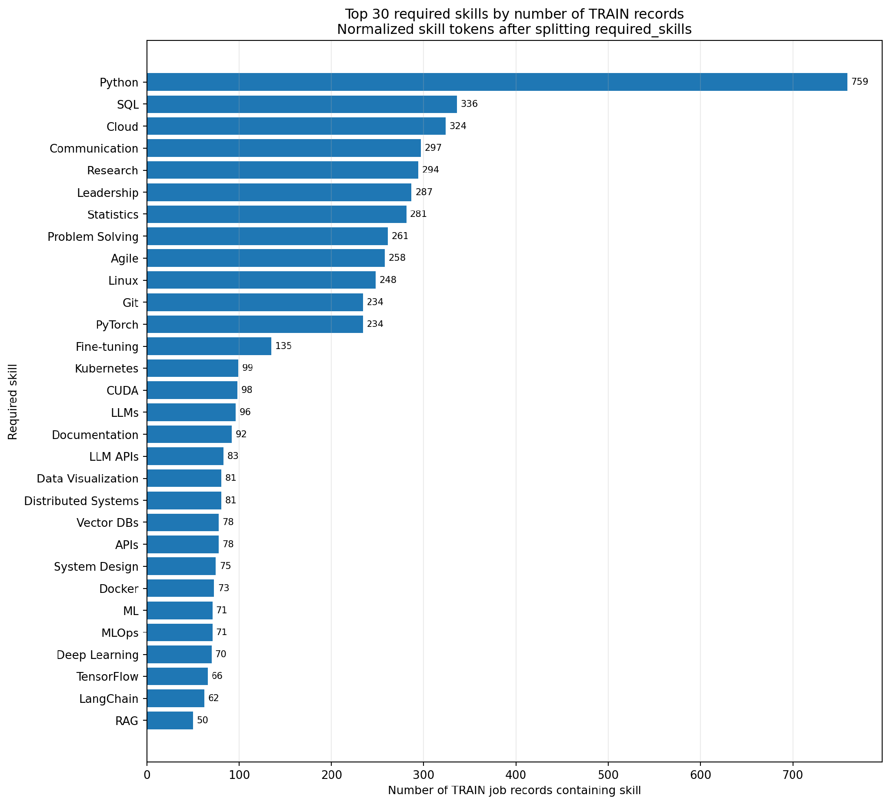
Figure 10. top 30 required skills on Train dataset.

- posting_year, posting_month, is_senior, is_remote_friendly, is_llm_role, ai_salary_premium_pct, demand_growth_yoy_pct — not used as modelling inputs
Redundant :
Issue | Observed evidence | Magnitude | Required action
Derived redundancy | is_senior exactly follows experience_level; is_remote_friendly exactly follows remote_work; is_llm_role is deterministic by job_title. | 0 mismatches for first two | Remove duplicate flags from the primary feature set.
Location redundancy | Each city maps to exactly one country in the current snapshot. | 20 cities -> 20 city-country pairs | Compare city-only, country-only and both; prefer stable generalization.

The final modelling feature set (11 columns): job_title, job_category (old name = AI Engineering), years_of_experience, education_required, city, country, remote_work, company_size, industry, demand_score, benefits_score_10 — with annual_salary_usd as the target.
# | Canonical column | Logical type | Observed domain / range | Data rule | ML role
0 | job_title | Nominal categorical | 25 categories | NOT NULL; unknown category được flag | KEEP
1 | job_category | Nominal categorical | 13 raw values; 12 valid + 1 corrupted | "job_category" là invalid value → loại row / quarantine | KEEP after cleaning
2 | years_of_experience | Integer numeric | 1–15 | integer ≥ 0; semantic consistency check | ABLATION
3 | education_required | Ordinal categorical | 5 levels | explicit ordered categories | KEEP
Target | annual_salary_usd | Integer numeric | 90,000–384,000 | > 0; NOT NULL | TARGET
4 | city | Nominal categorical | 20 cities | NOT NULL; unknown → OOD flag | KEEP / ABLATE
5 | country | Nominal categorical | 14 countries | NOT NULL; validate city-country pair | KEEP / ABLATE
6 | remote_work | Nominal categorical | On-site, Hybrid, Fully Remote | closed categorical domain | KEEP
7 | company_size | Ordinal/nominal categorical | 5 categories | controlled vocabulary | KEEP
8 | industry | Nominal categorical | 12 industries | controlled vocabulary | KEEP
P2 (*) | required_skills | Multi-label text | 1,500 unique strings; | delimited | tokenize (need separate NLP treatment) only after split; train-only vocabulary  thêm một cột đánh số lượng skill_count | PHASE 2
9 | demand_score | Integer numeric | 68–98 | numeric range validation | KEEP / ABLATE
10 | benefits_score_10 | Integer numeric | 6–10 | integer, recommended domain 0–10 | KEEP
Split | posting_year | Integer / temporal | 2025–2026 | required for temporal split | SPLIT / CONDITIONAL X
Split | posting_month | Integer / temporal | 1–12 | integer ∈ [1,12] | SPLIT / CONDITIONAL X

6.3. Target leakage investigation (Điều tra rò rỉ mục tiêu)
- Feature Availability and Leakage Policy: A predictor is eligible only if it is (a) semantically meaningful for the use case, (b) available at inference time, (c) not derived from the target or a post-target process, (d) not an identifier/proxy memorizer, and (e) stable enough to generalize across the temporal holdout. Correlation alone does not prove or disprove leakage; provenance and generation logic are required.
Policy | Features | Reason
BLOCK | job_id; salary_min_usd; salary_max_usd; salary_tier; is_senior; is_remote_friendly; is_llm_role | Identifiers, target-adjacent compensation fields, or deterministic redundant flags.
CONTRADICTORY ablation | years_of_experience; experience_level | Do not silently choose one as truth; compare feature families and document sensitivity.
CONDITIONAL | ai_salary_premium_pct; demand_growth_yoy_pct; posting_year; posting_month | Use only after availability/provenance and temporal-proxy checks.

- Required Feature-Family Ablation Experiments:
Experiment | Feature set | Decision question
A0 - Conservative | Core categorical + education + benefits; no experience; no target-adjacent fields. | Reference for plausibility.
A1 - + years | A0 + years_of_experience | Measure predictive gain from the suspicious numeric experience signal.
A2 - + experience bucket | A0 + experience_level, excluding numeric years | Compare the alternate experience representation.
A3 - Geography | Country-only vs city-only vs both | Check redundancy and unseen-location risk.
A4 - Demand | With vs without demand_score | Because demand_score is exactly determined by job_title.
A5 - Time | With vs without posting year/month | Detect temporal proxy dependence.
A6 - Skills (Phase 2) | Tokenized skills added to the selected structured feature set | Measure incremental signal without raw-string memorization.

STAGE 7. Correlation Encoding & Analysis
(PIC = Duy AI)
- All preprocessing lives inside a scikit-learn Pipeline/ColumnTransformer serialized with the model.
7.1. Imputation and Transformation:
- Imputation (Điền khuyết): Thực hiện tính toán (ví dụ: Median) trên tập Train và áp dụng giá trị đó lên tập Test. Với lương, nên dùng Median thay vì Mean vì lương thường có phân phối lệch (skewed).
- Log Transformation: Dữ liệu lương thường bị lệch phải (nhiều người lương thấp, ít người lương cực cao). Áp dụng log1p sẽ giúp phân phối chuẩn hơn, giúp các mô hình tuyến tính hoạt động hiệu quả hơn.
7.2. Correlation analysis & VIF - Variance Inflation Factor (Phân tích tương quan & Đa cộng tuyến) on Train:
- Correlation analysis (Phân tích tương quan): Sử dụng Pearson hoặc Spearman để xem các yếu tố như "Level", "Skill" tương quan thế nào với "Salary".
- VIF (Variance Inflation Factor): Kiểm tra hiện tượng đa cộng tuyến giữa các biến độc lập.
7.3. Encoding (Mã hóa):
- Nominal categoricals: OneHotEncoder job_title, AI Engineering, city, country, remote_work, company_size, industry — with handle_unknown="ignore" so unseen categories at prediction time don't crash the app; use min_frequency only if supported by validation and documented.
- Education: OrdinalEncoder with explicit order Bootcamp/Self-taught < Associate's < Bachelor's < Master's < PhD. Unknown values map to a dedicated fallback code.

- Numeric values (years_of_experience, demand_score, benefits_score_10): median imputation for inference robustness even though current training snapshot has no missing values; fit median on TRAIN only.
- Skills (Phase 2): split on |, trim, de-duplicate tokens, build vocabulary on TRAIN, optionally MultiLabelBinarizer / token TF-IDF. Raw required_skills string is prohibited as a single categorical value.
Issue | Observed evidence | Magnitude | Required action
Skills data quality | required_skills raw string is unique per row; 119 rows contain repeated tokens. | 1,500 strings; 93 distinct tokens | Never one-hot raw strings; split tokens, de-duplicate within row, fit vocabulary on TRAIN.

- Không one-hot trực tiếp chuỗi raw: Nếu bạn biến mỗi chuỗi kỹ năng thành một cột one-hot, sẽ có hàng nghìn cột duy nhất (vì mỗi chuỗi là khác nhau), dẫn đến dữ liệu nhiễu và không dùng được.
- Tách token (split tokens): Cần tách chuỗi kỹ năng thành các từ/tokens riêng lẻ (ví dụ: "Python, SQL, Machine Learning" → ["Python", "SQL", "Machine Learning"]).
- Loại trùng trong từng dòng (de-duplicate within row): Nếu một kỹ năng lặp lại nhiều lần trong cùng một dòng, chỉ giữ một lần.
- Xây vocabulary trên tập TRAIN (fit vocabulary on TRAIN): Tạo danh sách kỹ năng duy nhất từ tập train, sau đó encode dữ liệu theo danh sách này. Điều này đảm bảo mô hình chỉ học từ những kỹ năng đã thấy trong train, tránh mismatch khi gặp dữ liệu mới.
- Important caveat: pd.get_dummies is fine for a one-off analysis dataframe, but is not safe to reuse for the deployed model — the exact set of dummy columns it produces depends on which categories exist in the full dataset. A single new row from a form won't contain every category, so get_dummies would silently produce a mismatched column set. The actual modelling pipeline (Section 15) uses a proper ColumnTransformer instead, specifically to avoid this problem.
7.4. Scaling (Thay đổi quy mô):
- StandardScaler for Ridge/ElasticNet/SVR; not required for tree ensembles. Use model-specific pipelines rather than one universal preprocessing compromise.
7.5. Feature Selection:
- Bắt đầu bằng Lasso (L1 Regularization) để loại bỏ nhanh các biến rác vì nó nhanh và đơn giản.
- Sau đó, để độ chính xác cao hơn và hiểu sâu về sự tương tác giữa các kỹ năng, sử dụng RFE (Recursive Feature Elimination) kết hợp với mô hình mạnh mẽ như Random Forest và SVM.
- Tại sao cần dùng cho Dự án?
- Tránh "Lời nguyền đa chiều" (Curse of Dimensionality): Với hàng trăm kỹ năng AI khác nhau, nếu giữ lại tất cả, mô hình sẽ dễ bị quá khớp (overfitting) — tức là nó học thuộc lòng dữ liệu cũ nhưng dự báo sai cho ứng viên mới.
- Tăng khả năng giải thích (Interpretability): Một mô hình dự báo lương dựa trên 10 kỹ năng cốt lõi sẽ dễ dàng giải thích cho nhà tuyển dụng hoặc ứng viên hơn là một mô hình sử dụng 100 yếu tố hỗn tạp.
- Tối ưu hóa tài nguyên: Giảm số lượng đặc trưng giúp mô hình chạy nhanh hơn, tốn ít bộ nhớ hơn và dễ bảo trì hơn trong tương lai.
7.6. Feature Construction:
- Feature Construction (Xây dựng đặc trưng mới):
- Tạo biến "Salary-to-Experience Ratio" để hiểu giá trị của một năm kinh nghiệm trong các mảng AI khác nhau.
- Skill Grouping: Nhóm các kỹ năng AI (ví dụ: gom "PyTorch", "TensorFlow", "Keras" thành "Deep Learning Frameworks") để giảm số lượng biến và tăng tính tổng quát.
- Cross-Validation: Luôn sử dụng K-Fold Cross-Validation trên tập Train để đảm bảo mô hình ổn định trước khi đánh giá cuối cùng trên tập Test.
- Tập Test cuối cùng (Hold-out): Mar 2026 (chiếm 20% dữ liệu, dùng để đánh giá mô hình sau cùng sau khi đã chọn được hyperparameter tốt nhất).
- Các Fold để Cross-Validation trên tập Train (Jan 2025 – Jan 2026):
  - Fold 1: Train (Jan 2025 – May 2025); Validation (Jun 2025).
  - Fold 2: Train (Jan 2025 – Jun 2025); Validation (Jul 2025).
  - Fold 3: Train (Jan 2025 – Jul 2025); Validation (Aug 2025).
  - Fold 4: Train (Jan 2025 – Aug 2025); Validation (Sep 2025).
  - Fold 5: Train (Jan 2025 – Sep 2025); Validation (Oct 2025).
  - Tiếp tục cho đến Feb 2026.
- Hướng dẫn thực hiện kỹ thuật (Logic Code): Để triển khai 5 folds này một cách chuẩn xác, bạn cần tuân thủ các quy tắc sau từ nguồn tài liệu:
- Tham số n_splits: Thiết lập n_splits=5 trong hàm TimeSeriesSplit của thư viện Scikit-Learn.
- Không xáo trộn (No Shuffling): Luôn đảm bảo shuffle=False để giữ đúng trình tự thời gian.
- Tính toán thống kê: Mọi bước như chuẩn hóa (Scaling) hay điền khuyết (Imputation) phải được tính toán thông số (.fit) trên phần Train của từng fold và chỉ áp dụng (.transform) lên phần Validation tương ứng để tránh rò rỉ thông tin.
- Cách đánh giá kết quả từ 5 Folds: Sau khi chạy xong 5 folds, bạn cần thực hiện các bên dưới.
- Tính điểm trung bình (Mean Score): Lấy trung bình cộng kết quả của 5 fold để có cái nhìn tổng quát về hiệu suất mô hình.
- Kiểm tra độ lệch chuẩn (Std Dev):
  - Nếu độ lệch giữa các fold thấp: Mô hình ổn định.
  - Nếu độ lệch cao (High Variance): Mô hình đang nhạy cảm với dữ liệu và có nguy cơ quá khớp (overfitting).
- So sánh với Baseline: Kết quả trung bình này phải cao hơn mô hình Dummy (mô hình dự đoán ngẫu nhiên) để đảm bảo mô hình có giá trị sử dụng.
- Residual Analysis (Phân tích phần dư): Sau khi huấn luyện, hãy kiểm tra biểu đồ phần dư để xem mô hình có dự đoán sai lệch nhiều ở các mức lương quá cao hay quá thấp hay không.
7.7. Preprocessing Contract:
- Configuration Contract
project:
name: ai_job_market_salary_prediction
seed: 42
data:
path: data/raw/ai_jobs_market_2025_2026.csv
target: annual_salary_usd
canonical_rename:
"AI Engineering": job_category
split:
strategy: temporal
locked_test:
year: 2026
month: 3
features:
blocked: [job_id, salary_min_usd, salary_max_usd, salary_tier,
is_senior, is_remote_friendly, is_llm_role]
contradictory: [years_of_experience, experience_level]
phase2: [required_skills]
metrics:
primary: MAE
secondary: [RMSE, R2, MedAE]
artifacts:
output_root: outputs
bundle_path: artifacts/model_bundle.joblib
Configuration rule: Thresholds, allowed features, split dates, model search spaces and narrative acceptance criteria must live in versioned config files, not scattered as hard-coded constants across notebooks and Streamlit.

- Stage Failure Policy
Failure | Pipeline response
Required column missing / wrong dtype | Fail closed; no training or serving. Emit schema error with column-level detail.
Invalid categorical token | Quarantine/drop if confidently corrupted and very low-volume; otherwise stop for rule decision.
Blocked feature enters X | Raise runtime error; invalidate experiment.
Preprocessing fitted before split | Invalidate run and rebuild from raw data.
Locked test used during tuning | Invalidate final performance estimate; create a new governed holdout if possible.
Unknown category at inference | Encode safely; set unseen-category flag; monitor rate.
Out-of-range numeric input | Predict only if policy allows; attach out-of-distribution / review flag.
Bundle reload changes prediction | Deployment release fails; do not serve.

STAGE 8. Train-Test Split
(PIC = Minh)
- Data followed time series:
- The split was performed on the raw cleaned df (not the get_dummies df_corr), since the modelling pipeline does its own encoding internally via ColumnTransformer
- training / testing: select all records of [posting_year = 2026, posting_month = 3] for testing (about 20%), the historical data for train (around 80%).
- Train shape: approximately 1,199 rows × 11 columns
- Test shape: approximately 300 rows × 11 columns
- Locked-test rule. 2026-03 is not part of CV. Test labels are not inspected until the feature set, model class, hyperparameters, interval policy and narrative template are frozen.
- Each candidate model was wrapped in a single scikit-learn Pipeline containing a ColumnTransformer preprocessor, so the saved artifact is the entire pipeline — encoder and model together.

BEFORE VS AFTER DATA PROCESSING
Aspect | Before Processing | After Processing
Data Structure | Raw, 25 columns incl. IDs, leakage & free text | Clean, 11 modelling features, leakage-free
Corrupted Values | Header value leaked into a data row (hidden) | Identified & removed
Experience Signals | Two contradictory experience columns | Investigated; redundant column dropped
Encoding | Unsafe pd.get_dummies (analysis-only) | Deployable ColumnTransformer pipeline
Target Leakage | High risk (salary_min/max/tier present) | Fully eliminated
Model Readiness | Not Ready | Fully Ready — single deployable artifact

This comparison highlights how a data-quality-first approach — going beyond nulls and duplicates — was essential to turning this dataset into a trustworthy modelling input.

STAGE 9. Model Training & Comparison
(basic + ensemble model)

.3 Baseline and Candidate Model Ladder
Model | Role | Technical rationale
DummyRegressor (median) | Non-ML floor | Any promoted model must materially outperform this.
Linear Regression | Transparent linear baseline | Detect whether relationships are mostly additive.
Ridge / ElasticNet | Regularized linear baseline | Stable with many one-hot features; coefficients are auditable.
Random Forest | Nonlinear bagging baseline | Robust tabular comparator; inspect overfit and inference size.
Extra Trees | High-variance-reduction tree ensemble | Strong tabular diagnostic; validate stability.
Gradient Boosting / HistGradientBoosting | Primary advanced scikit-learn candidate | Strong nonlinear tabular candidate; tune depth/learning rate/regularization.
SVR RBF | Optional diagnostic | Requires scaling; sparse high-dimensional OHE may be unfavorable.
CatBoost / LightGBM / XGBoost | Optional extension | Use only if dependency policy allows; compare fairly using same splits and metrics.

6.4 Hyperparameter Tuning Rules
- Tuning is nested inside the development data and temporal folds; the final test is never passed to a search object.
- Prefer RandomizedSearchCV or a small bounded search space because the dataset has only ~1.2k development rows after holdout.
- Optimize primary metric = negative MAE or a weighted multi-metric decision, while recording RMSE, R2 and fold variance.
- Every trial logs model parameters, feature-set ID, split/fold IDs, seed, train time, inference time and metrics.
- If two candidates are statistically/practically similar, select the simpler, more stable and more interpretable candidate.

6.5 Evaluation Metrics
Metric | Formula | Priority | Interpretation
MAE | (1/n) * sum |y_i - yhat_i| | Primary | Directly interpretable as average absolute USD error; robust relative to RMSE.
RMSE | sqrt((1/n) * sum (y_i - yhat_i)^2) | Primary secondary | Penalizes large salary misses more strongly.
R2 | 1 - SS_res / SS_tot | Diagnostic | Fraction of variance explained on the evaluated split; can be misleading when data generation is synthetic.
Median AE | median(|y_i - yhat_i|) | Robust diagnostic | Shows typical error less affected by a few large residuals.
Interval coverage | mean(y_i in [L_i, U_i]) | If intervals enabled | Empirical coverage of prediction interval; not the same as parameter confidence interval.
Interval width | mean(U_i - L_i) | If intervals enabled | Coverage must be considered together with useful width.

6.6 Model Promotion Criteria
Gate | GO condition
Predictive value | MAE/RMSE materially beat Dummy and are stable across temporal folds.
Temporal generalization | Locked-test degradation is understood and acceptable; no hidden tuning against test.
Feature plausibility | No blocked fields; suspicious feature-family gains are documented by ablation.
Error slices | No severe unexplained degradation in adequately supported role/domain/location slices.
Complexity | Inference time, artifact size and maintenance burden justified by incremental performance.
Explainability | Global and local explanation available; no causal claims.
Reproducibility | Run can be reproduced from fingerprint + config + environment + seed.
Deployment equivalence | Reloaded bundle yields numerically equivalent predictions to offline pipeline.

9.1. Five regression models were trained and compared on the identical train/test split:
- Linear Regression — simplest interpretable baseline
- Ridge Regression — linear plus regularization, handles many one-hot columns better than plain linear
- Random Forest — nonlinear, handles mixed feature types without scaling
- Gradient Boosting — usually the strongest of these on tabular data
- SVM (RBF kernel) — nonlinear but distance-based, needs scaled inputs
9.2. Ensemble Model:
- Hyperparameter tuning (GridSearchCV / RandomizedSearchCV), especially for Gradient Boosting
- Ensemble stacking of the strongest models
- Re-investigating years_of_experience once a corrected, verified dataset is available
9.3. Need to read result from output, example:
Model | MAE | RMSE | R² Score
Gradient Boosting | 14,522.78 | 25,808.91 | 0.852
Random Forest | 14,742.45 | 27,639.93 | 0.830
Ridge Regression | 25,347.58 | 35,734.20 | 0.716
Linear Regression | 25,393.36 | 35,754.04 | 0.716
SVM (RBF kernel) | 47,989.42 | 64,351.12 | 0.080

Ex: Gradient Boosting achieved the best performance (R² = 0.852), narrowly ahead of Random Forest (R² = 0.830). Both linear models performed identically and far behind the tree-based models, while the SVM landed close to a dummy-baseline result. This is not a tuning mistake — it reflects a structural mismatch: SVR with an RBF kernel measures distance in feature space, and after one-hot encoding this dataset has roughly 100 dimensions, most of them sparse binary indicators. Distance-based methods degrade badly in exactly that setting, while tree-based splits are unaffected by how many sparse dummy columns exist.

STAGE 10. Best Model Selection & Feature Importance Review
10.1. Best model: Gradient Boosting (test R² = 0.852)
10.2. Top Feature Importances:
- AI Engineering_AI Engineering (core domain): 0.7237 — dominant driver of the model's predictions
- years_of_experience: 0.2056
- AI Engineering_Security: 0.0119
- AI Engineering_Robotics: 0.0092
- AI Engineering_Architecture: 0.0076
- All remaining features individually contribute well under 1% each
Caution: these two features alone (AI Engineering domain + years_of_experience) account for over 92% of the model's total feature importance. Since years_of_experience carries the contradictory, likely-synthetic signal flagged in Section 10, the model's strong R² should be reported honestly as a good fit to this specific dataset — not oversold as a fully causal, real-world explanation of AI salaries. Feature importance was deliberately inspected here rather than accepting the R² score at face value.

STAGE 11. Save Deployable Pipeline + Metadata
- The winning pipeline was split into its preprocessing step and its final estimator, then saved as separate reusable artifacts:
- preprocessor.pkl — the fitted preprocessing pipeline (encodes raw columns into model-ready features)
- model.pkl — the trained Gradient Boosting estimator
- feature_columns.json — the exact raw column order the preprocessor expects as input
- metadata.json — best_model_name, test_r2, test_mae, category_options (valid values seen per categorical column during training), numeric_ranges (min/max seen for numeric columns), and ordinal_order (the education ranking)
- To save the full pipeline and supporting metadata as deployable artifacts: Saving category_options and numeric_ranges alongside the model lets the Streamlit UI build dropdowns and sliders that only offer values the model actually learned from, instead of guessing or allowing invalid inputs.

STAGE 12. Streamlit Salary Prediction Dashboard
- Visualize data and inllustrate pie, bar, line, statistics graph/ chart and table followed above 12 stages of pineline on Streamlit:
- Performing data quality checks that go beyond nulls and duplicates — catching corrupted values hidden inside categorical columns
- Investigating and reasoning critically about contradictory features before trusting either of them
- Applying the correct ordinal vs nominal encoding strategy for different categorical variables
- Building deployment-safe preprocessing with ColumnTransformer + Pipeline instead of ad-hoc pd.get_dummies
- Fairly comparing multiple regression algorithms on an identical train/test split
- Interpreting feature importance critically rather than accepting a strong R² at face value
- Packaging a full ML pipeline and supporting metadata for real-time deployment via Streamlit
- Advanced Analytics
- Predicting a salary range/confidence interval instead of a single point estimate: build an interactive Streamlit dashboard for real-time salary prediction
- Geographic salary-adjustment modelling (cost-of-living aware)
- Skill-based salary premium analysis using required_skills via NLP

D – CODE IMPLEMENTATION
Dataset: ai_jobs_market_2025_2026.csv (1,500 AI job postings, 25 attributes)

D.1. salary_predict_corrected.ipynb File
# Import the libraries and Load the dataset
import pandas as pd
import numpy as np

# NOTE: update this path to match your local machine
df = pd.read_csv("C:\\Users\\mayank manjhi\\Downloads\\list_projects\\Ai_job_market\\data\\ai_jobs_market_2025_2026.csv")

# Data's Initial Inspection Load the raw dataset and review a sample of records to understand its structure.
df.head(5)

df.info()

df.describe().round(2)

# Data Quality Checks Check nulls, duplicates, **and** sanity-check every categorical column's values *before* doing any correlation or feature work. This step was missing before, and it's what catches corrupted values that `.isnull()` and `.duplicated()` won't.
print("Null values in each column:\n", df.isnull().sum())
print("=" * 50)
print("Duplicate rows:", df.duplicated().sum())

# Sanity-check every categorical column's values, not just null/duplicate counts.
# This is what catches corrupted or unexpected values sitting inside otherwise "clean" columns.
categorical_cols = df.select_dtypes(include=["object"]).columns.tolist()
for col in categorical_cols:
print(f"\n--- {col} ({df[col].nunique()} unique values) ---")
print(df[col].value_counts())

**Finding:** the `AI Engineering` column contains a value `"job_category"` (count = 1) — that is literally the column header leaked into the data as a row value (job_id `AIJOB1205`). This would have silently corrupted any encoding/correlation work downstream. Fixing it now, before feature selection.
bad_rows = df[df["AI Engineering"] == "job_category"]
print(f"Corrupted rows found: {len(bad_rows)}")
display(bad_rows)

# Only 1 row out of 1500 — drop it rather than guess/impute a category.
df = df[df["AI Engineering"] != "job_category"].reset_index(drop=True)
print("Row count after cleanup:", len(df))

# Investigate Suspicious Relationships Before Modeling `years_of_experience` and `experience_level` should tell a consistent story (more experience -> higher pay). Check that assumption before trusting either column as a feature.
print("Mean salary by experience_level (categorical bucket):")
print(df.groupby("experience_level")["annual_salary_usd"].mean().round(0))
print()
print("Mean salary by years_of_experience (raw numeric):")
print(df.groupby("years_of_experience")["annual_salary_usd"].mean().round(0))

**Finding:** `experience_level` shows salaries flat across Entry/Mid/Senior/Lead (~$193k-196k each), while `years_of_experience` shows a strong *downward* trend (1 yr -> ~$326k, 15 yrs -> ~$90k). These two columns directly contradict each other and cannot both be reliable signals of real-world pay-for-experience. This is a data quality issue in the source dataset (very likely a synthetic dataset with a generation bug), not something to encode around silently. Decision taken here: keep `years_of_experience` as a feature since it's the more granular of the two, drop the redundant `experience_level` bucket, and flag this relationship as unreliable/synthetic rather than trusting it as a real causal signal in any write-up.
# Feature Selection Remove columns that either leak the target (derived directly from salary) or aren't useful as modeling inputs (IDs, free-text, redundant buckets).
leak_and_unused_cols = [
"job_id", # identifier, not a feature
"salary_min_usd", # leaks target (derived from same salary structure)
"salary_max_usd", # leaks target
"salary_tier", # leaks target (binned version of the target)
"experience_level", # redundant with years_of_experience, and contradicts it (see above)
"required_skills", # free text, would need separate NLP treatment
"posting_year",
"posting_month",
"is_senior",
"is_remote_friendly",
"is_llm_role",
"ai_salary_premium_pct",
"demand_growth_yoy_pct",
]

df = df.drop(columns=leak_and_unused_cols)
df.head()

# Encoding for Correlation Analysis Build a *separate* encoded copy for correlation analysis (`df_corr`). This uses `pd.get_dummies`, which is fine for a one-off analysis dataframe but is **not safe to reuse for the deployed model** — the exact set of dummy columns it produces depends on which categories exist in the full dataset. A single new row (e.g. from a form) won't contain all those categories, so `get_dummies` would silently produce a mismatched column set. The modeling section further down uses a proper `ColumnTransformer` instead, for exactly this reason. Corrected encoding logic (same reasoning as before): - **Ordinal columns** (have a real order) -> map to an explicit rank, not LabelEncoder's alphabetical default. `education_required` is the one ordinal column here. - **Nominal columns** (no real order) -> one-hot encode, regardless of how many unique values they have.
df_corr = df.copy()

# Ordinal: education has a real ranking, so encode it as one
education_order = {
"Bootcamp/Self-taught": 0,
"Associate's": 1,
"Bachelor's": 2,
"Master's": 3,
"PhD": 4,
}
df_corr["education_required"] = df_corr["education_required"].map(education_order)

# Nominal: one-hot encode everything else that's still categorical, regardless of cardinality
nominal_cols_for_corr = df_corr.select_dtypes(include=["object"]).columns.tolist()
print("One-hot encoding (correlation view only):", nominal_cols_for_corr)

df_corr = pd.get_dummies(df_corr, columns=nominal_cols_for_corr, drop_first=False)
df_corr.head()

# Correlation Analysis (single pass, on the corrected encoding)
target_corr = df_corr.corr(numeric_only=True)["annual_salary_usd"].sort_values(ascending=False)
target_corr

import matplotlib.pyplot as plt

# A full heatmap is unreadable once job_title/city/etc are one-hot encoded (90+ columns).
# A sorted bar chart of correlation with the target is the readable equivalent.
top_corr = target_corr.drop("annual_salary_usd").reindex(
target_corr.drop("annual_salary_usd").abs().sort_values(ascending=False).index
).head(25)

plt.figure(figsize=(10, 8), dpi=100)
colors = ["#d62728" if v < 0 else "#2ca02c" for v in top_corr.values]
plt.barh(top_corr.index[::-1], top_corr.values[::-1], color=colors[::-1])
plt.axvline(0, color="black", linewidth=0.8)
plt.title("Top 25 Features by |Correlation| with annual_salary_usd")
plt.xlabel("Correlation")
plt.tight_layout()
plt.show()

**Note on interpreting this correlation table:** one-hot dummy columns (e.g. `AI Engineering_Security`, `job_title_LLM Engineer`) are binary indicators, so their correlation with salary is meaningful — it tells you whether *belonging to that specific category* is associated with higher or lower pay. That is different from the old approach, where a single LabelEncoder column mixed all categories into one arbitrary numeric scale and produced a correlation number that depended on alphabetical order, not on the actual data. Any `job_title`/`AI Engineering` correlation you read from this table now reflects a real category-level relationship, not an encoding artifact.
# Train/Test Split for Modeling Splitting the **raw cleaned `df`** (not `df_corr`) — the modeling pipeline below does its own encoding internally via `ColumnTransformer`, so it needs the original untouched columns, not the `get_dummies` output.
from sklearn.model_selection import train_test_split

X = df.drop(columns=["annual_salary_usd"])
y = df["annual_salary_usd"]

X_train, X_test, y_train, y_test = train_test_split(
X, y, test_size=0.2, random_state=42
)

print("Train shape:", X_train.shape)
print("Test shape:", X_test.shape)

# Model Selection Compare a few baseline regressors on the same train/test split before committing to one. Including a `DummyRegressor` (predicts the mean every time) as a sanity-check floor — any real model should clearly beat it, otherwise the features aren't adding value. Each model is wrapped in a `Pipeline` with a `ColumnTransformer` preprocessor (ordinal-encode `education_required`, one-hot encode the rest with `handle_unknown="ignore"`, pass numeric columns through unchanged). This means the **saved artifact is the whole pipeline** — encoder and model together — so it can take a single raw new row later (e.g. from a Streamlit form) without needing a separate encoder kept in sync by hand. Models compared: - **Linear Regression** — simplest interpretable baseline - **Ridge Regression** — linear + regularization, handles the many one-hot columns better than plain linear - **Random Forest** — nonlinear, handles mixed feature types without scaling - **Gradient Boosting** — usually the strongest of these on tabular data, slower to train - **SVM (RBF kernel)** — nonlinear, but distance-based so it needs scaled inputs; often struggles on high-dimensional one-hot data like this without careful tuning
from sklearn.compose import ColumnTransformer
from sklearn.pipeline import Pipeline
from sklearn.preprocessing import OneHotEncoder, OrdinalEncoder, StandardScaler
from sklearn.linear_model import LinearRegression, Ridge
from sklearn.ensemble import RandomForestRegressor, GradientBoostingRegressor
from sklearn.dummy import DummyRegressor
from sklearn.svm import SVR
from sklearn.metrics import mean_absolute_error, mean_squared_error, r2_score

ordinal_col = ["education_required"]
ordinal_categories = [["Bootcamp/Self-taught", "Associate's", "Bachelor's", "Master's", "PhD"]]
nominal_cols = [c for c in X.select_dtypes(include=["object"]).columns if c not in ordinal_col]
numeric_cols = [c for c in X.columns if c not in nominal_cols + ordinal_col]

print("Ordinal:", ordinal_col)
print("Nominal (one-hot):", nominal_cols)
print("Numeric (passthrough):", numeric_cols)

def make_preprocessor():
# Fresh ColumnTransformer per model -- avoids sharing fitted state across pipelines.
return ColumnTransformer(
transformers=[
("ordinal", OrdinalEncoder(categories=ordinal_categories), ordinal_col),
("onehot", OneHotEncoder(handle_unknown="ignore", sparse_output=False), nominal_cols),
],
remainder="passthrough",
)

models = {

"Linear Regression": Pipeline([
("preprocess", make_preprocessor()),
("model", LinearRegression()),
]),
"Ridge Regression": Pipeline([
("preprocess", make_preprocessor()),
("model", Ridge(alpha=1.0, random_state=42)),
]),
"Random Forest": Pipeline([
("preprocess", make_preprocessor()),
("model", RandomForestRegressor(n_estimators=300, random_state=42, n_jobs=-1)),
]),
"Gradient Boosting": Pipeline([
("preprocess", make_preprocessor()),
("model", GradientBoostingRegressor(random_state=42)),
]),
"SVM (RBF kernel)": Pipeline([
("preprocess", make_preprocessor()),
("scale", StandardScaler()),
("model", SVR(kernel="rbf", C=1000, epsilon=1000)),
]),
}

results = []
fitted_models = {}

for name, model in models.items():
model.fit(X_train, y_train)
preds = model.predict(X_test)

mae = mean_absolute_error(y_test, preds)
rmse = mean_squared_error(y_test, preds) ** 0.5
r2 = r2_score(y_test, preds)

results.append({"model": name, "MAE": mae, "RMSE": rmse, "R2": r2})
fitted_models[name] = model

results_df = pd.DataFrame(results).sort_values("R2", ascending=False).reset_index(drop=True)
results_df.round(3)

import matplotlib.pyplot as plt

plt.figure(figsize=(8, 5), dpi=100)
plt.barh(results_df["model"][::-1], results_df["R2"][::-1], color="#1f77b4")
plt.axvline(0, color="black", linewidth=0.8)
plt.xlabel("R2 on test set")
plt.title("Model Comparison — Test Set R2")
plt.tight_layout()
plt.show()

**Reading the comparison:** the best model here is whichever has the highest R2 / lowest RMSE — check the table above rather than assuming Gradient Boosting wins by default, since that depends on this specific split and feature set. **On the SVM result specifically:** don't be surprised if it lands at or below the dummy baseline. `C`/`epsilon` tuning outside this notebook only reached R2 ~0.08, nowhere near the tree models' ~0.85. This isn't a tuning mistake, it's a structural mismatch: SVR with an RBF kernel measures distance in feature space, and this dataset is ~100 dimensions after one-hot encoding, most of them sparse binary indicators. Distance-based methods degrade in exactly that setting, while tree-based splits don't care how many sparse dummy columns exist. **Caveat carried over from the correlation step:** `years_of_experience` has a strong negative relationship with salary that contradicts `experience_level`'s (dropped) flat relationship. If the best model is leaning heavily on `years_of_experience`, that's the model learning a pattern that may be a synthetic-data artifact rather than a real-world signal. Check feature importance below before trusting this model on new data — don't just take the R2 at face value.
best_model_name = results_df.iloc[0]["model"]
best_pipeline = fitted_models[best_model_name]
print("Best model by R2:", best_model_name)

preprocess_step = best_pipeline.named_steps["preprocess"]
feature_names = preprocess_step.get_feature_names_out()
final_estimator = best_pipeline.named_steps["model"]

if hasattr(final_estimator, "feature_importances_"):
importances = pd.Series(final_estimator.feature_importances_, index=feature_names)
importances = importances.sort_values(ascending=False).head(15)
print("\nTop 15 feature importances:")
print(importances.round(4))
elif hasattr(final_estimator, "coef_"):
coefs = pd.Series(final_estimator.coef_, index=feature_names)
coefs = coefs.reindex(coefs.abs().sort_values(ascending=False).index).head(15)
print("\nTop 15 coefficients by magnitude:")
print(coefs.round(2))
else:
print("No importances/coefficients exposed by this model type.")

# Save the Best Model as a Deployable Artifact The object saved below is the **entire pipeline** — preprocessing *and* model together — not just the raw estimator. That's the point of building it with `ColumnTransformer` earlier: hand it a single raw row with the original column names (`job_title`, `AI Engineering`, `years_of_experience`, `education_required`, `city`, `country`, `remote_work`, `company_size`, `industry`, `demand_score`, `benefits_score_10`) and it encodes + predicts in one call. No separate encoder to keep in sync by hand — which matters once this gets used from something like a Streamlit app. Also saving a small `model_metadata.json` alongside it: the valid category values and numeric ranges seen during training, so a UI can build dropdowns/sliders that only offer values the model actually knows about, instead of guessing.
import joblib
import json
from pathlib import Path
from sklearn.pipeline import Pipeline as SkPipeline

# Where to save artifacts — adjust if you want a different location
artifacts_dir = Path("artifacts")
artifacts_dir.mkdir(exist_ok=True)

# Split the winning pipeline into its preprocessing steps and its final estimator.
# Works regardless of which model won (e.g. SVM has an extra "scale" step, trees don't).
steps = dict(best_pipeline.named_steps)
model = steps.pop("model")
preprocessor = SkPipeline(list(steps.items()))

# 1. The fitted preprocessor (encodes raw columns -> model-ready features)
joblib.dump(preprocessor, artifacts_dir / "preprocessor.pkl")

# 2. The trained model (fits on the preprocessor's output)
joblib.dump(model, artifacts_dir / "model.pkl")

# 3. The exact raw column order the preprocessor expects as input
feature_columns = X_train.columns.tolist()
with open(artifacts_dir / "feature_columns.json", "w") as f:
json.dump(feature_columns, f, indent=2)

# 4. Everything a UI needs to build valid inputs + show model context
metadata = {
"best_model_name": best_model_name,
"test_r2": float(results_df.iloc[0]["R2"]),
"test_mae": float(results_df.iloc[0]["MAE"]),
"category_options": {
col: sorted(X_train[col].dropna().unique().tolist())
for col in nominal_cols + ordinal_col
},
"numeric_ranges": {
col: {"min": int(X_train[col].min()), "max": int(X_train[col].max())}
for col in numeric_cols
},
"ordinal_order": {"education_required": ordinal_categories[0]},
}
with open(artifacts_dir / "metadata.json", "w") as f:
json.dump(metadata, f, indent=2)

print("Saved:", sorted(p.name for p in artifacts_dir.iterdir()))
print(f"Best model: {best_model_name} (test R2 = {metadata['test_r2']:.3f})")

D.2. app.py File — Streamlit Salary Predictor
Unlike a multi-file backend, this project keeps everything — artifact loading, prediction logic, and the UI — inside a single app.py script. Below is a walkthrough of what each part does, followed by the full code.
2.1 Imports, Paths & Page Setup
The script imports joblib and pandas for loading the trained pipeline and building input rows, and streamlit for the UI. ARTIFACTS_DIR is computed relative to app.py's own file location (Path(__file__).parent / "artifacts"), so the artifacts/ folder must sit next to app.py. st.set_page_config() sets the browser tab title, a 💰 icon, a wide layout, and a collapsed sidebar, since this app doesn't use one.
2.2 Custom Styling
A block of custom CSS is injected via st.markdown(..., unsafe_allow_html=True) to move away from Streamlit's default look: a centered, bold blue title, a muted subtitle, a rounded bordered box around the input form, and a blue-to-purple gradient card used later to display the predicted salary.
2.3 Loading the Model (Cached)
The load() function is decorated with @st.cache_resource, so the preprocessor, model, feature column list, and metadata are only loaded from disk once per server session, not on every user interaction or form submission. _require() checks each artifact file exists first and calls st.stop() with a clear error message if anything is missing, rather than crashing with a raw file-not-found traceback.
2.4 The predict() Function
This is the entire inference step: it wraps the incoming inputs dictionary in a single-row DataFrame, reindexes its columns to match cols (the exact feature_columns.json order the model was trained on — filling in any structurally missing column as NaN rather than erroring), passes that row through the fitted preprocessor (pre.transform), and returns the model's single prediction as a plain float.
2.5 Reading Metadata for the Form
Right after loading, the script pulls three things out of metadata.json: cats (valid category options per column), ranges (min/max for numeric columns), and education_order (the ordinal ranking for education_required). These drive every dropdown and slider below, so the form can never offer a value the model wasn't trained on.
2.6 Header & Live Model Metrics
The page title and subtitle are rendered, followed by a 3-column metric row showing metadata["best_model_name"], the test R² score (to 3 decimals), and the test MAE (formatted as a dollar amount) — so the model's own reported accuracy is visible to the user directly above the prediction form, not hidden away.
2.7 The Prediction Form
All inputs are grouped inside a single st.form("prediction"), which means Streamlit won't re-run the whole script on every individual widget change — only when the form is submitted. Inputs are split into two columns:
- Left column: Job Title, AI Engineering (domain), Years of Experience (slider bounded by the trained min/max), Education (ordered dropdown), Country
- Right column: Remote Work, Company Size, Industry, Demand Score (slider), Benefits Score (slider)
Note that city is not collected from the user — the file comment ("Country only UI") and the DEFAULT_CITY = "Unknown" constant show this was a deliberate simplification, sending a fixed placeholder city value to the model instead of asking the user to pick one.
2.8 Handling Submission & Displaying the Result
When "🚀 Predict Salary" is clicked, the script assembles an inputs dictionary using the exact column names the model expects (job_title, "AI Engineering", years_of_experience, education_required, city, country, remote_work, company_size, industry, demand_score, benefits_score_10), calls predict() inside a spinner, and renders the result inside the gradient "prediction" card defined in the CSS — showing the estimated annual salary formatted with thousands separators and the winning model's name underneath. A small table below echoes back every value the user submitted, as a transparency check.
2.9 Full Code

"""
AI Job Market Salary Predictor
Complete Streamlit App (Country only UI)
"""

import json
from pathlib import Path

import joblib
import pandas as pd
import streamlit as st

ARTIFACTS_DIR = Path(__file__).parent / "artifacts"
PREPROCESSOR_PATH = ARTIFACTS_DIR / "preprocessor.pkl"
MODEL_PATH = ARTIFACTS_DIR / "model.pkl"
FEATURE_COLUMNS_PATH = ARTIFACTS_DIR / "feature_columns.json"
METADATA_PATH = ARTIFACTS_DIR / "metadata.json"

DEFAULT_CITY = "Unknown" # Change if your model expects a specific city.

st.set_page_config(
page_title="AI Job Salary Predictor",
page_icon="💰",
layout="wide",
initial_sidebar_state="collapsed",
)

st.markdown("""
<style>
.block-container{max-width:1200px;padding-top:2rem}
.main-title{text-align:center;font-size:42px;font-weight:800;color:#2563eb}
.sub-title{text-align:center;color:#6b7280;margin-bottom:1rem}
div[data-testid="stForm"]{
padding:1.5rem;
border-radius:16px;
border:1px solid rgba(120,120,120,.25);
}
.prediction{
background:linear-gradient(135deg,#2563eb,#7c3aed);
padding:2rem;
border-radius:18px;
text-align:center;
color:white;
}
.prediction *{color:white!important}
.footer{text-align:center;color:gray;margin-top:2rem}
</style>
""", unsafe_allow_html=True)

def _require(path):
if not path.exists():
st.error(f"Missing artifact: {path}")
st.stop()

@st.cache_resource
def load():
for p in [PREPROCESSOR_PATH, MODEL_PATH, FEATURE_COLUMNS_PATH, METADATA_PATH]:
_require(p)
pre = joblib.load(PREPROCESSOR_PATH)
model = joblib.load(MODEL_PATH)
cols = json.loads(FEATURE_COLUMNS_PATH.read_text())
meta = json.loads(METADATA_PATH.read_text())
return pre, model, cols, meta

def predict(pre, model, cols, inputs):
row = pd.DataFrame([inputs])
row = row.reindex(columns=cols)
x = pre.transform(row)
return float(model.predict(x)[0])

pre, model, feature_columns, metadata = load()

cats = metadata["category_options"]
ranges = metadata["numeric_ranges"]
education_order = metadata["ordinal_order"]["education_required"]

st.markdown('<div class="main-title">💰 AI Job Market Salary Predictor</div>', unsafe_allow_html=True)
st.markdown('<div class="sub-title">Predict AI salaries using Machine Learning</div>', unsafe_allow_html=True)

m1,m2,m3=st.columns(3)
m1.metric("Model",metadata["best_model_name"])
m2.metric("Test R²",f'{metadata["test_r2"]:.3f}')
m3.metric("MAE",f'${metadata["test_mae"]:,.0f}')

with st.form("prediction"):
c1,c2=st.columns(2)
with c1:
job_title=st.selectbox("Job Title",cats["job_title"])
ai=st.selectbox("AI Engineering",cats["AI Engineering"])
exp=st.slider("Years of Experience",
ranges["years_of_experience"]["min"],
ranges["years_of_experience"]["max"],5)
edu=st.selectbox("Education",education_order)
country=st.selectbox("Country",cats["country"])
with c2:
remote=st.selectbox("Remote Work",cats["remote_work"])
company=st.selectbox("Company Size",cats["company_size"])
industry=st.selectbox("Industry",cats["industry"])
demand=st.slider("Demand Score",
ranges["demand_score"]["min"],
ranges["demand_score"]["max"],
(ranges["demand_score"]["min"]+ranges["demand_score"]["max"])//2)
benefits=st.slider("Benefits Score",
ranges["benefits_score_10"]["min"],
ranges["benefits_score_10"]["max"],
(ranges["benefits_score_10"]["min"]+ranges["benefits_score_10"]["max"])//2)

submit=st.form_submit_button("🚀 Predict Salary",use_container_width=True)

if submit:
inputs={
"job_title":job_title,
"AI Engineering":ai,
"years_of_experience":exp,
"education_required":edu,
"city":DEFAULT_CITY,
"country":country,
"remote_work":remote,
"company_size":company,
"industry":industry,
"demand_score":demand,
"benefits_score_10":benefits,
}

with st.spinner("Predicting..."):
salary=predict(pre,model,feature_columns,inputs)

st.markdown(f"""
<div class="prediction">
<h2>Estimated Annual Salary</h2>
<h1>${salary:,.0f}</h1>
<p>{metadata["best_model_name"]}</p>
</div>
""",unsafe_allow_html=True)

st.dataframe(pd.DataFrame(inputs.items(),columns=["Feature","Value"]),
use_container_width=True,hide_index=True)

st.markdown('<div class="footer">Built with Streamlit • Scikit-learn • Python</div>',
unsafe_allow_html=True)

E – INSTALLATION & HOW TO RUN THE PROJECT

Project Folder Structure: Based on the file paths referenced inside the notebook and app.py, the project should be organized as follows — app.py and the notebook should sit in the same root folder, since both expect an artifacts/ folder as a direct sibling:
Ai_job_market/
├── artifacts/ (created by the notebook: preprocessor.pkl,
│ model.pkl, feature_columns.json, metadata.json)
├── data/
│ └── ai_jobs_market_2025_2026.csv (raw dataset)
├── salary_predict_corrected.ipynb (data cleaning + EDA + model training)
└── app.py (Streamlit dashboard)
All commands below should be run from inside the Ai_job_market/ root folder.

Step 1: Install the required libraries
Open a terminal in the project root and run:
pip install pandas numpy matplotlib scikit-learn joblib streamlit jupyter

Step 2: Run the data cleaning, EDA & model-training notebook
Update the pd.read_csv(...) path near the top of the notebook to point at data/ai_jobs_market_2025_2026.csv on your machine, then launch Jupyter:
jupyter notebook salary_predict_corrected.ipynb
Run all cells in order (Cell → Run All). This performs the data quality checks, drops the corrupted row and leakage columns, trains and compares five regression models, and finally saves the winning pipeline and metadata into an artifacts/ folder — the "Save the Best Model as a Deployable Artifact" step at the end of the notebook.

Step 3: Launch the Streamlit dashboard
Once artifacts/ has been created by the notebook, start the dashboard from the project root:
streamlit run app.py
This opens the AI Job Market Salary Predictor in your browser at http://localhost:8501, where you can fill in the job/role form and click "🚀 Predict Salary" to get an instant estimate, model name, and accuracy metrics (see the Streamlit Dashboard section below).

F - CONCLUSION AND FUTURE DEVELOPMENT

F.1 | Data Basic Clean  A null-free dataset was not accepted at face value; logic and categorical corruption were audited.

1500  Raw rows | 25  Raw columns | 0  Missing cells | 0  Duplicates

Basic structural checks found 0 missing cells and 0 duplicate rows. However, the categorical sanity check identified one corrupted row in the source field 'AI Engineering': the literal header value 'job_category' appeared as a record value. That row was removed and the field was canonically renamed to job_category, producing 1,499 clean records.
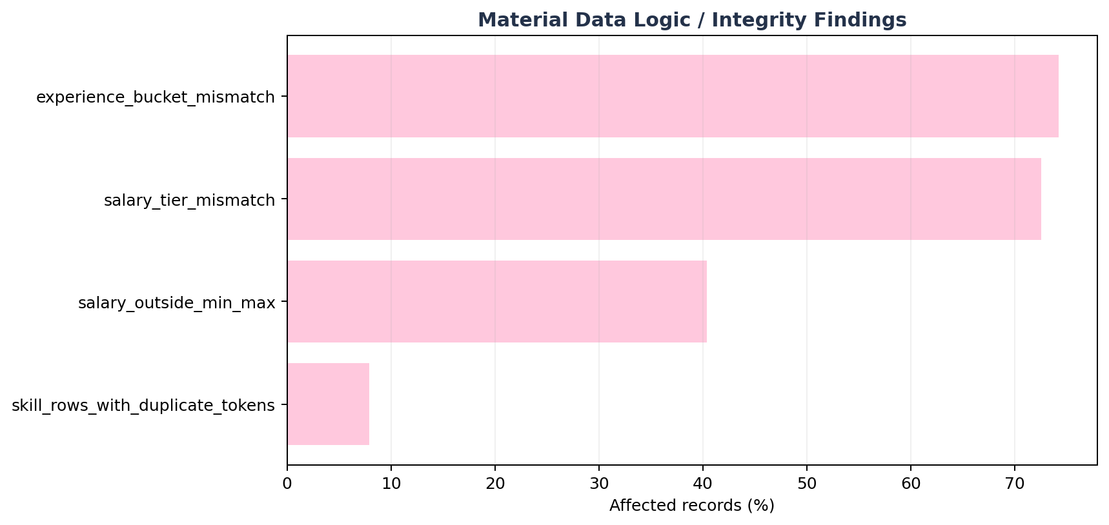
Figure 1. Share of clean rows affected by major logic/integrity findings.

issue | affected_rows | affected_pct | action
experience_bucket_mismatch | 1113 | 74.2% | Drop experience_level from primary model; retain years_of_experience as an ablation-sensitive numeric feature.
salary_outside_min_max | 605 | 40.4% | Block salary_min_usd and salary_max_usd from X.
salary_tier_mismatch | 1,087 | 72.5% | Block salary_tier from X.
skill_rows_with_duplicate_tokens | 118 | 7.9% | De-duplicate skill tokens within each row before multi-hot encoding.

Conclusion – Data basic clean Structural cleanliness alone would have been misleading. The cleaned output is suitable for controlled modeling only after blocking inconsistent target-adjacent fields and explicitly treating experience semantics as a synthetic-risk warning.

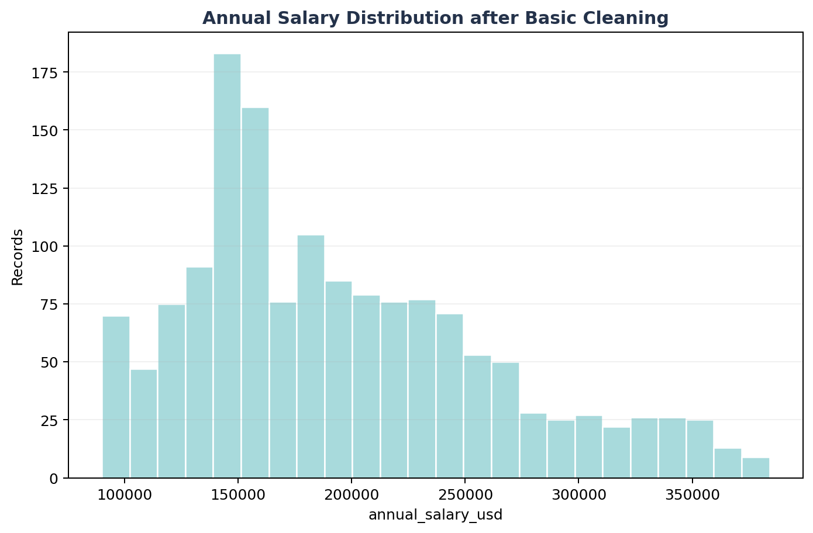
Figure 2. Target distribution after basic cleaning.

F.2 | Data Ready for Machine Learning  Leakage gate, temporal split, TRAIN-only encoding/scaling, multi-hot skills and skill_count.

1,201  TRAIN / DEV | 298  Locked Test | 93  Skill vocabulary | 189  Encoded features

The model input retains the technical design's 11 structured predictors and adds a skill-aware Phase-2 enhancement: required_skills is normalized into distinct pipe-separated tokens, multi-hot encoded by a vocabulary learned only from TRAIN/DEV, and accompanied by skill_count (distinct token count). In this supplied snapshot the TRAIN vocabulary contains 93 tokens.
Allowed model inputs:
feature | role
job_title | KEEP
job_category | KEEP
years_of_experience | KEEP
education_required | KEEP
city | KEEP
country | KEEP
remote_work | KEEP
company_size | KEEP
industry | KEEP
demand_score | KEEP
benefits_score_10 | KEEP
required_skills | PHASE2_MULTI_HOT
skill_count | ENGINEERED

Blocked fields include identifiers, target-adjacent salary metadata, contradictory/redundant experience flags, and non-serving metadata. This protects the model from learning the answer directly or from unstable derived signals.
feature | reason
job_id | Identifier, redundant/contradictory, derived flag, or non-serving metadata
salary_min_usd | Target leakage / target-adjacent
salary_max_usd | Target leakage / target-adjacent
salary_tier | Target leakage / target-adjacent
experience_level | Identifier, redundant/contradictory, derived flag, or non-serving metadata
posting_year | Identifier, redundant/contradictory, derived flag, or non-serving metadata
posting_month | Identifier, redundant/contradictory, derived flag, or non-serving metadata
is_senior | Identifier, redundant/contradictory, derived flag, or non-serving metadata
is_remote_friendly | Identifier, redundant/contradictory, derived flag, or non-serving metadata
is_llm_role | Identifier, redundant/contradictory, derived flag, or non-serving metadata
ai_salary_premium_pct | Identifier, redundant/contradictory, derived flag, or non-serving metadata
demand_growth_yoy_pct | Identifier, redundant/contradictory, derived flag, or non-serving metadata

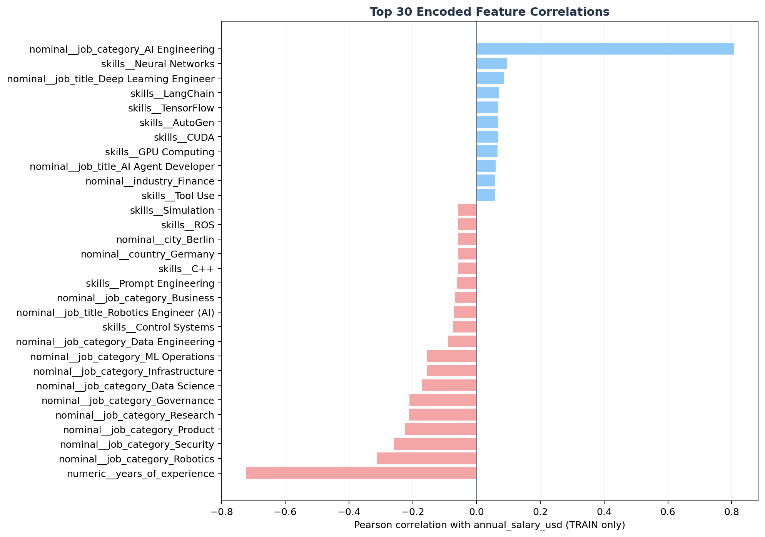
Figure 3. Top 30 TRAIN-only encoded correlations with annual_salary_usd.
Conclusion – Data ready for ML The encoded dataset is ready for modeling with 189 numeric columns. The strongest TRAIN-only encoded correlation is nominal__job_category_AI Engineering (r=+0.807); this is diagnostic association, not causal evidence.

F.3 | Model Comparison  Five regression families evaluated on the same expanding monthly temporal-validation folds.

Figure 4. Temporal CV MAE across five candidate regression models.

Figure 5. Mean temporal CV R² by model family.

Conclusion – Model Comparison Select Random Forest using development-period evidence. The locked March-2026 test remains outside candidate comparison and is opened only after this selection/tuning decision is frozen.

F.4 | Best Model Selection & Importance Feature Review  Final one-time locked-test evaluation plus model-behavior diagnostics.

Random Forest  Best model | $14,961  MAE | $29,844  RMSE | 0.803  R² | $4,467  MedAE

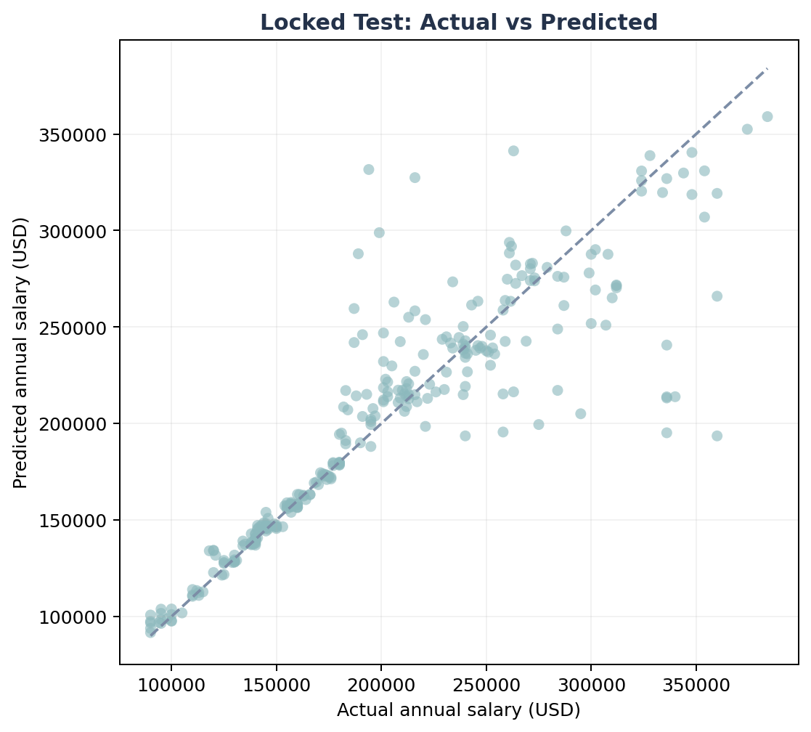
Figure 6. Locked test: actual versus predicted annual salary.
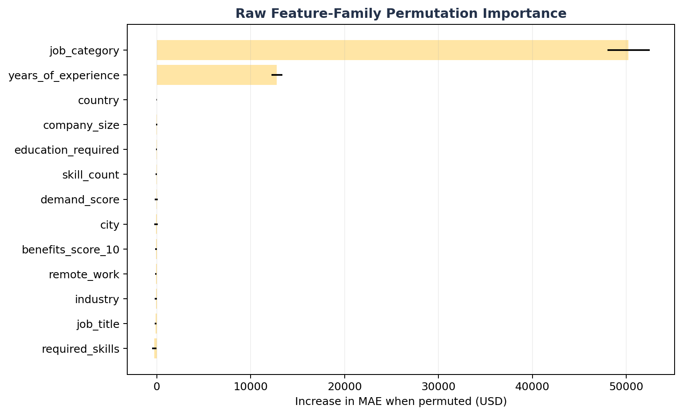
Figure 7. Raw feature-family permutation importance measured on final test.
raw_feature | importance_mean | importance_std
job_category | $50,242 | $2,246
years_of_experience | $12,796 | $600
country | $5 | $22
company_size | $-27 | $60
education_required | $-41 | $63
skill_count | $-48 | $72
demand_score | $-56 | $176
city | $-65 | $187

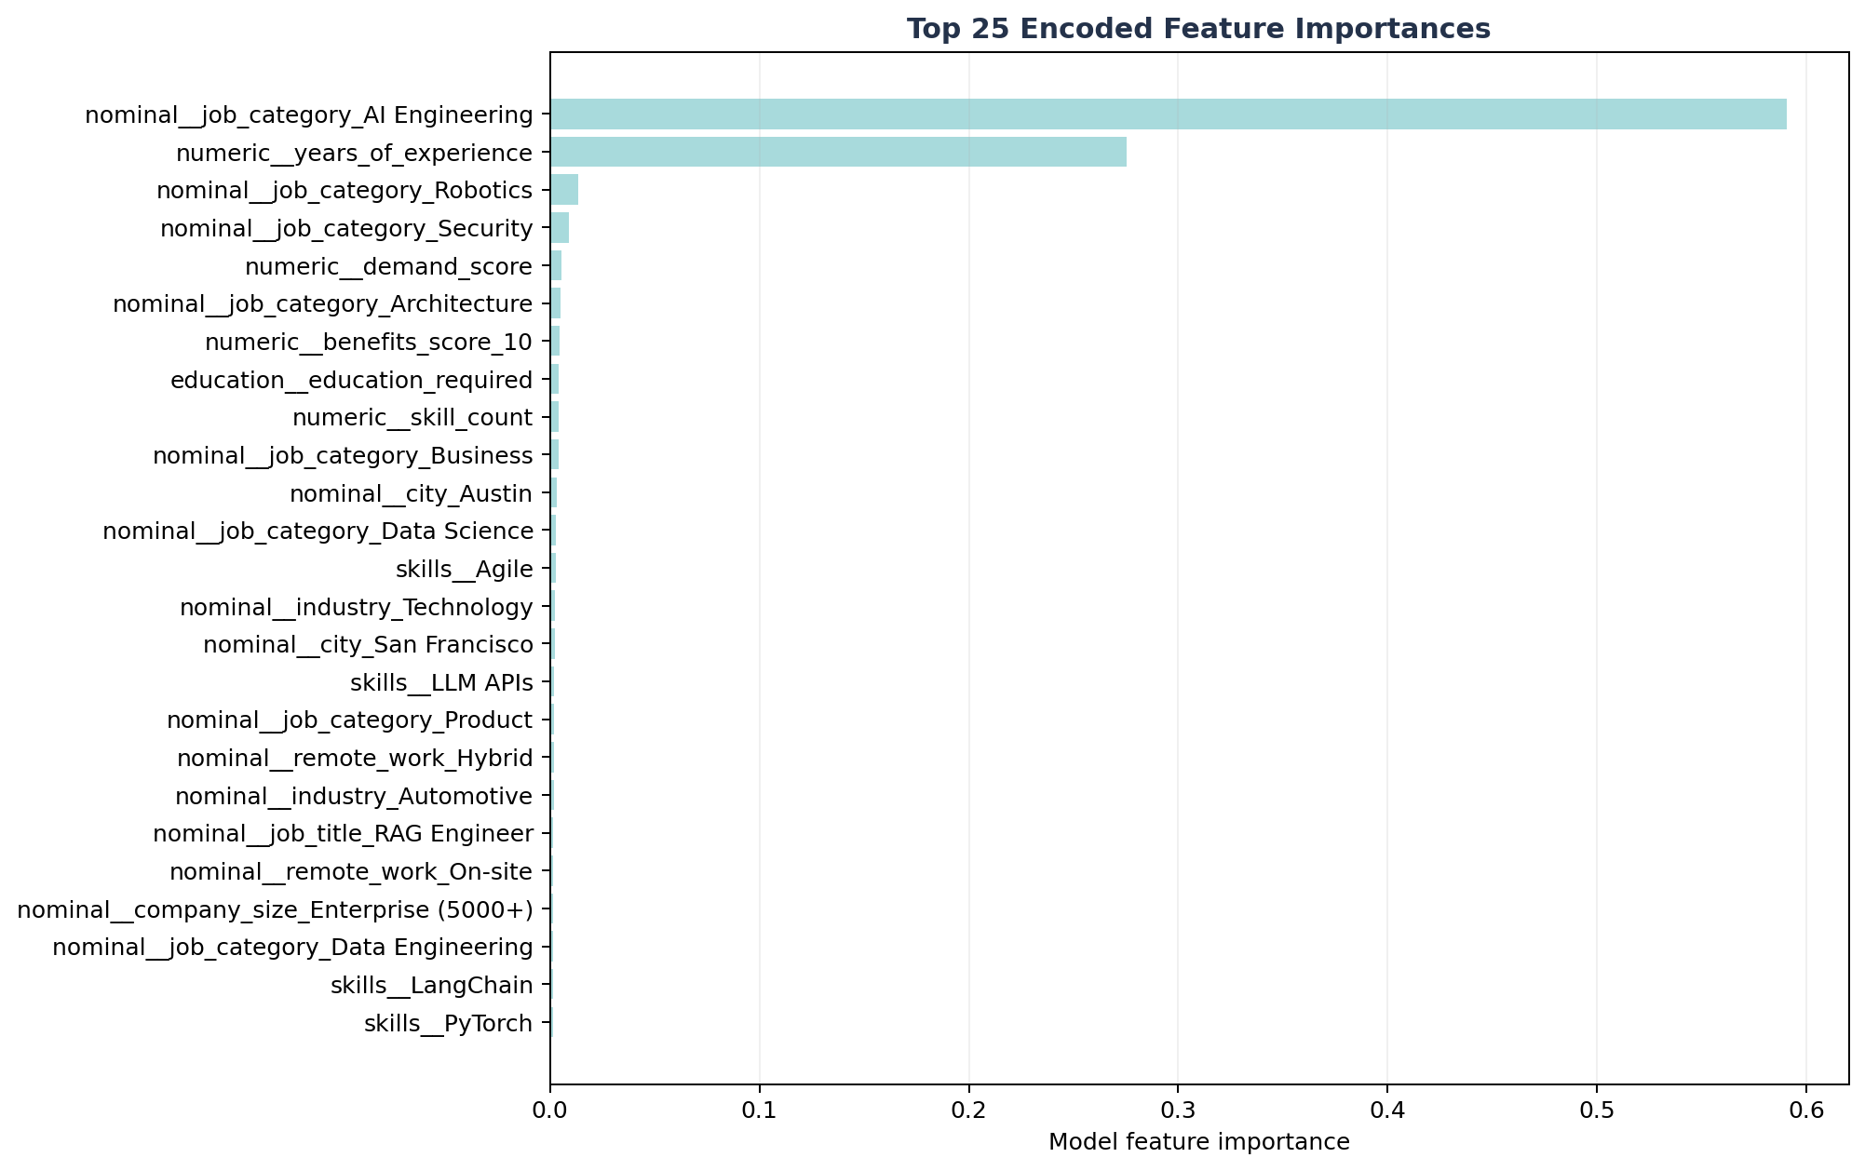
Figure 8. Top encoded feature importances inside the selected estimator.
encoded_feature | importance
nominal__job_category_AI Engineering | 0.5908
numeric__years_of_experience | 0.2753
nominal__job_category_Robotics | 0.0136
nominal__job_category_Security | 0.0091
numeric__demand_score | 0.0054
nominal__job_category_Architecture | 0.0050
numeric__benefits_score_10 | 0.0044
education__education_required | 0.0042
numeric__skill_count | 0.0041
nominal__job_category_Business | 0.0041

Conclusion – Best model & importance The final locked-test R² is 0.803. Permutation evidence is dominated by job_category and years_of_experience. Because these are embedded in a dataset with contradictory and synthetic-looking structure, their importance must be reported as model reliance rather than causal salary drivers.
F.5 | AI Market Job Salary Prediction  Deployable bundle, authenticated Streamlit interface and practical prediction interval.

298  Locked test rows | $197,787  Mean prediction | $194,694  Median prediction | $32,216  90% half-width

The selected Random Forest pipeline is serialized as artifacts/model_bundle.joblib together with metadata.json. Streamlit reads the same feature contract, category options, numeric ranges, 93-skill vocabulary and empirical validation-error interval used by the offline model. This avoids manual encoder/model mismatch during interactive prediction.

Figure 11. Salary prediction performance on the final locked period.
job_title | job_category | city | annual_salary_usd | predicted_salary_usd | absolute_error_usd
Data Scientist | AI Engineering | New York | $190,000 | $189,995 | $5
LLM Engineer | Infrastructure | Singapore | $140,000 | $139,978 | $22
Generative AI Engineer | Infrastructure | Bangalore | $140,000 | $140,025 | $25
AI Research Scientist | Governance | Bangalore | $146,000 | $146,074 | $74
Multimodal AI Engineer | ML Operations | San Francisco | $138,000 | $138,085 | $85
Deep Learning Engineer | Architecture | Austin | $180,000 | $179,911 | $89
Deep Learning Engineer | Infrastructure | Tokyo | $140,000 | $139,910 | $90
NLP Engineer | Data Science | Los Angeles | $157,000 | $156,892 | $108

Streamlit login The delivered streamlit.py includes a local demo login (admin / AIJob2026!) and supports replacement via Streamlit secrets or AIJOB_APP_USER + AIJOB_APP_PASSWORD_SHA256 environment variables. The demo credential must be changed before any shared deployment.

Conclusion – Salary Prediction The final model is suitable for academic salary benchmarking and scenario exploration inside this dataset’s empirical scope. A practical interval of approximately ±$32,216 is shown to communicate uncertainty instead of presenting an unexplained point estimate only.

G - REFERENCES
- eBook
- eBook
- eBook
- eBook

H - TASK ASSIGNMENT TABLE
TASK ASSIGNMENT TABLE
No. | Main task | Student name | Completion - %
1 | Load data & Data Quality Check | Gia Bảo
2 | Contradictory-Feature Investigation, Feature Selection & Correlation Analysis | Nguyễn Kim Ngân
3 | Encoding, Scaling, Feature Engineer, and Leakage Prevention | Duy AI
4 | Model Training & Comparison, Best Model Selection and Feature Importance Review | Huỳnh Minh
5 | Streamlit Salary Prediction Dashboard & Visualization | Tạ Gia Hiển

STAGE | NGƯỜI PHỤ TRÁCH | GHI CHÚ
1. Load Data | Bảo | Sau bước này có data cơ bản clean
2. Project Scope & Initial Inspection | Bảo
3. Data Quality Check | Bảo
4. Corrupted Row Removal | Bảo
5. Contradictory-Feature Investigation | Ngân | Sau bước này có data ready cho train model
6. Feature Selection & Leakage Preventaion | Ngân & Duy AI
7. Correlation Encoding & Analysis | Duy AI
8. Train-Test Split | Minh | Sau bước này chọn được model và tính năng quan trọng
9. Model Training & Comparison | Minh
10. Best Model Selection & Feature Importance Review | Minh
11. Save Deployable Pipeline + Metadata | Hiển | Đây là module dựng dự đoán lương cho tương lai khi nhập thông tin vào feature X
12. Streamlit Salary Prediction Dashboard | Hiển

- Data Dictionary and Modeling Role – before cleaning:
Source column | dtype | Observed domain | Role | Policy | Technical note
job_id | object | 1500 unique | ID | BLOCK | Identifier; suffix is strongly ordered with salary.
job_title | object | 25 unique | Nominal | KEEP | Core role feature; 25 categories.
job_category (old name = AI Engineering) | object | 13 unique | Nominal | KEEP after cleaning | Canonical rename to job_category; remove invalid row value "job_category".
experience_level | object | 4 unique | Ordinal/category | ABLATION | Semantically inconsistent with years_of_experience; do not trust blindly.
years_of_experience | int64 | 1 .. 15; 15 unique | Numeric | ABLATION | Strong predictive signal but implausible downward salary relationship; production promotion requires provenance.
education_required | object | 5 unique | Ordinal | KEEP | Explicit ordered encoder; unknown categories -> -1 or dedicated Unknown.
annual_salary_usd | int64 | 90000 .. 384000; 248 unique | Target | TARGET | Regression target only.
salary_min_usd | int64 | 90000 .. 180000; 17 unique | Target-adjacent | BLOCK primary | Fixed by job_title and annual salary lies outside stated range in 40.3% of rows.
salary_max_usd | int64 | 180000 .. 320000; 16 unique | Target-adjacent | BLOCK primary | Fixed by job_title; logically inconsistent with target for many rows.
city | object | 20 unique | Nominal | KEEP/ABLATE | 20 values; deterministically maps to country in this snapshot.
country | object | 14 unique | Nominal | KEEP/ABLATE | 14 values; redundant with city for current snapshot.
remote_work | object | 3 unique | Nominal | KEEP | 3 categories.
company_size | object | 5 unique | Nominal | KEEP | 5 categories.
industry | object | 12 unique | Nominal | KEEP | 12 categories.
required_skills | object | 1500 unique | Multi-label text | PHASE 2 | Raw string is unique in all 1,500 rows; tokenize by | into train-only vocabulary (93 observed tokens).
ai_salary_premium_pct | float64 | 3 .. 18; 151 unique | Numeric | CONDITIONAL | Use only if provenance confirms it is available before target and not computed from compensation.
demand_score | int64 | 68 .. 98; 20 unique | Numeric | KEEP/ABLATE | 20 values; exact function of job_title in this snapshot, so it adds no independent information if title is present.
demand_growth_yoy_pct | float64 | 5 .. 87.8; 565 unique | Numeric | CONDITIONAL | Availability/provenance gate; excluded from conservative baseline.
benefits_score_10 | int64 | 6 .. 10; 5 unique | Numeric | KEEP | Observed range 6-10.
posting_year | int64 | 2025 .. 2026; 2 unique | Temporal | SPLIT / CONDITIONAL X | Required for temporal split; use as feature only if deployment date is known and ablation supports it.
posting_month | int64 | 1 .. 12; 12 unique | Temporal | SPLIT / CONDITIONAL X | Same as posting_year; avoid full-dataset temporal preprocessing.
is_senior | int64 | 0 .. 1; 2 unique | Derived flag | BLOCK primary | Exact deterministic derivative of experience_level in supplied data.
is_remote_friendly | int64 | 0 .. 1; 2 unique | Derived flag | BLOCK primary | Exact deterministic derivative of remote_work in supplied data.
is_llm_role | int64 | 0 .. 1; 2 unique | Derived flag | BLOCK primary | Deterministic by job_title in supplied data; redundant if job_title is present.
salary_tier | object | 5 unique | Target-adjacent | BLOCK primary | Only 27.5% consistent with annual_salary_usd band; not safe as predictor or evaluation label.

